TROZY

Use-case Model and Use-case Specification – Rental Management System

Version 1.0

Revision History
Date | Version | Description | Author
23/Oct/26 | 1.0 | Use-case model and specifications of 73 use cases across 23 modules | GROUP 11

Table of Contents
1. Use-case Model 6
1.1 Actors 6
1.2 Overall Use-case Diagram 7
1.3 Use-case Diagram: Accounts and Properties (M01–M02) 8
1.4 Use-case Diagram: Rooms and Tenants (M03–M04) 9
1.5 Use-case Diagram: Contracts and Utility Meters (M05–M06) 10
1.6 Use-case Diagram: Services, Invoices and Payments (M07–M09) 11
1.7 Use-case Diagram: Deposits, Income/Expenses, Tenant Portal and Maintenance (M10–M13) 12
1.8 Use-case Diagram: Assets, Handover and Notifications (M14–M16) 13
1.9 Use-case Diagram: Communication, Documents and Vehicles (M17–M19) 13
1.10 Use-case Diagram: Reports, Configuration, Analytics and AI (M20–M23) 14
1.11 Use-case List 14
2. Use-case Specifications 16
2.1 Module M01: Account and Authentication Management 16
2.1.1 Use-case: UC01 – Register Account 16
2.1.2 Use-case: UC02 – Verify Email 17
2.1.3 Use-case: UC03 – Log In 18
2.1.4 Use-case: UC04 – Log Out 18
2.1.5 Use-case: UC05 – Change and Reset Password 19
2.1.6 Use-case: UC06 – Manage Personal Information 19
2.1.7 Use-case: UC07 – Configure Notification Preferences 20
2.2 Module M02: Property and Building Management 20
2.2.1 Use-case: UC08 – Manage Properties and Buildings 20
2.2.2 Use-case: UC09 – Configure House Rules, Billing Day and Shared Services 21
2.2.3 Use-case: UC10 – View Room Overview by Property 22
2.2.4 Use-case: UC11 – View Property Information and House Rules 22
2.3 Module M03: Room Management 22
2.3.1 Use-case: UC12 – Manage Rooms 22
2.3.2 Use-case: UC13 – Update Room Status 23
2.3.3 Use-case: UC14 – Search Rooms and View Rental History 24
2.4 Module M04: Tenant and Room Member Management 24
2.4.1 Use-case: UC15 – Manage Tenant Profiles 24
2.4.2 Use-case: UC16 – Extract Document Information with OCR 25
2.4.3 Use-case: UC17 – Manage Occupancy 26
2.4.4 Use-case: UC18 – Invite and Link Tenant Account 26
2.4.5 Use-case: UC19 – View Residency Profile and Request Information Update 27
2.5 Module M05: Rental Contract Management 28
2.5.1 Use-case: UC20 – Create Rental Contract 28
2.5.2 Use-case: UC21 – Extend Contract and Create Addendum 28
2.5.3 Use-case: UC22 – Terminate Contract 29
2.5.4 Use-case: UC23 – Track Expiring Contracts 30
2.5.5 Use-case: UC24 – View, Download and Confirm Contract 30
2.5.6 Use-case: UC25 – Submit Contract Extension or Termination Request 31
2.6 Module M06: Utility Meter Management 31
2.6.1 Use-case: UC26 – Configure Meters and Utility Rates 31
2.6.2 Use-case: UC27 – Record and Finalize Meter Readings 32
2.6.3 Use-case: UC28 – Recognize Meter Readings with OCR 33
2.6.4 Use-case: UC29 – View Utility Readings and Charges 34
2.7 Module M07: Service and Surcharge Management 34
2.7.1 Use-case: UC30 – Manage Services and Surcharges 34
2.7.2 Use-case: UC31 – View Services and Applicable Charges 35
2.8 Module M08: Invoice Management 35
2.8.1 Use-case: UC32 – Generate Periodic Invoices 35
2.8.2 Use-case: UC33 – Adjust and Issue Invoices 36
2.8.3 Use-case: UC34 – View and Download Invoices 36
2.8.4 Use-case: UC35 – Submit Invoice Review Request 37
2.9 Module M09: Payment and Debt Management 37
2.9.1 Use-case: UC36 – Configure Receiving Account and Generate VietQR Code 37
2.9.2 Use-case: UC37 – Confirm Payment 38
2.9.3 Use-case: UC38 – Track Debts and Send Payment Reminders 39
2.9.4 Use-case: UC39 – Pay via QR and View Payment History 39
2.10 Module M10: Security Deposit and Refund Management 40
2.10.1 Use-case: UC40 – Record and Track Security Deposit 40
2.10.2 Use-case: UC41 – Settle and Refund Security Deposit 40
2.11 Module M11: Income and Expense Management 41
2.11.1 Use-case: UC42 – Record Income and Expenses 41
2.11.2 Use-case: UC43 – View and Export Income-Expense Reports 41
2.12 Module M12: Tenant Portal 42
2.12.1 Use-case: UC44 – View Tenant Portal Dashboard 42
2.13 Module M13: Maintenance and Incident Request Management 42
2.13.1 Use-case: UC45 – Create Repair Request 42
2.13.2 Use-case: UC46 – AI Classification and Repair Ticket Assistance 43
2.13.3 Use-case: UC47 – Receive and Process Maintenance Requests 44
2.13.4 Use-case: UC48 – Track, Confirm and Rate Issue Resolution 44
2.14 Module M14: Asset and Equipment Management 45
2.14.1 Use-case: UC49 – Manage Assets and Equipment 45
2.15 Module M15: Handover and Move-out Management 45
2.15.1 Use-case: UC50 – Create Move-in Handover Record 45
2.15.2 Use-case: UC51 – Receive Move-out Request and Inspect Condition 46
2.15.3 Use-case: UC52 – Finalize Settlement and Close Tenancy 46
2.16 Module M16: Notifications and Reminders 47
2.16.1 Use-case: UC53 – Send Notifications 47
2.16.2 Use-case: UC54 – Automatic Reminders 48
2.16.3 Use-case: UC55 – View Notifications 48
2.17 Module M17: Communication and Request Resolution 49
2.17.1 Use-case: UC56 – Submit Requests and Feedback 49
2.17.2 Use-case: UC57 – Respond to and Resolve Requests 49
2.18 Module M18: Records, Documents and House Rules Management 50
2.18.1 Use-case: UC58 – Manage Documents, Records and House Rules 50
2.18.2 Use-case: UC59 – Search and Download Documents 50
2.19 Module M19: Vehicle and Amenity Management 51
2.19.1 Use-case: UC60 – Manage Vehicles 51
2.19.2 Use-case: UC61 – Manage and Book Shared Amenities 51
2.20 Module M20: Dashboard and Summary Reports 52
2.20.1 Use-case: UC62 – View Dashboard and Summary Reports 52
2.20.2 Use-case: UC63 – View Personal Costs and Payment History 52
2.20.3 Use-case: UC64 – View Forecast of Debts, Revenue and Vacancies 53
2.21 Module M21: Configuration and Data Administration 53
2.21.1 Use-case: UC65 – Configure System 53
2.21.2 Use-case: UC66 – Import Data from Excel 54
2.21.3 Use-case: UC67 – Export and Back Up Data 54
2.21.4 Use-case: UC68 – View Business Change Log 55
2.22 Module M22: Smart Utility Insights 55
2.22.1 Use-case: UC69 – View Utility Consumption Statistics 55
2.22.2 Use-case: UC70 – Detect and Alert Utility Anomalies 56
2.23 Module M23: AI Rental Assistant 56
2.23.1 Use-case: UC71 – Ask the AI Assistant 56
2.23.2 Use-case: UC72 – Query Operational Data in Natural Language 57
2.23.3 Use-case: UC73 – Compose Notifications with AI 58

Use-case Model

Actors
The system has only two business actors. Every use case is subject to the authorization rule: a Landlord manages only the data of the properties under their ownership; a Tenant accesses only data related to themselves, their room and the contract they are authorized for.
Actor | Description and responsibilities
Landlord | Sets up properties and rooms; creates tenant profiles and contracts; manages utility readings, services, invoices, debts, security deposits and income/expenses; handles incidents and handovers; views reports and configures the system.
Tenant | Views room, contract, invoice and cost information; tracks payments and the security deposit; submits repair, extension and move-out requests; receives notifications and uses smart features within the permitted scope.

Note: operations triggered automatically by the system on a schedule (periodic invoice generation, reminders, anomaly detection) are described in the corresponding use cases; they do not constitute a third actor. The AI, OCR and forecasting features only provide assistance; decisions about security deposits, contracts and confirming receipt of money always belong to the Landlord.

Overall Use-case Diagram
Figure 1 – Overview of the 5 business groups, 23 modules and 73 use cases.
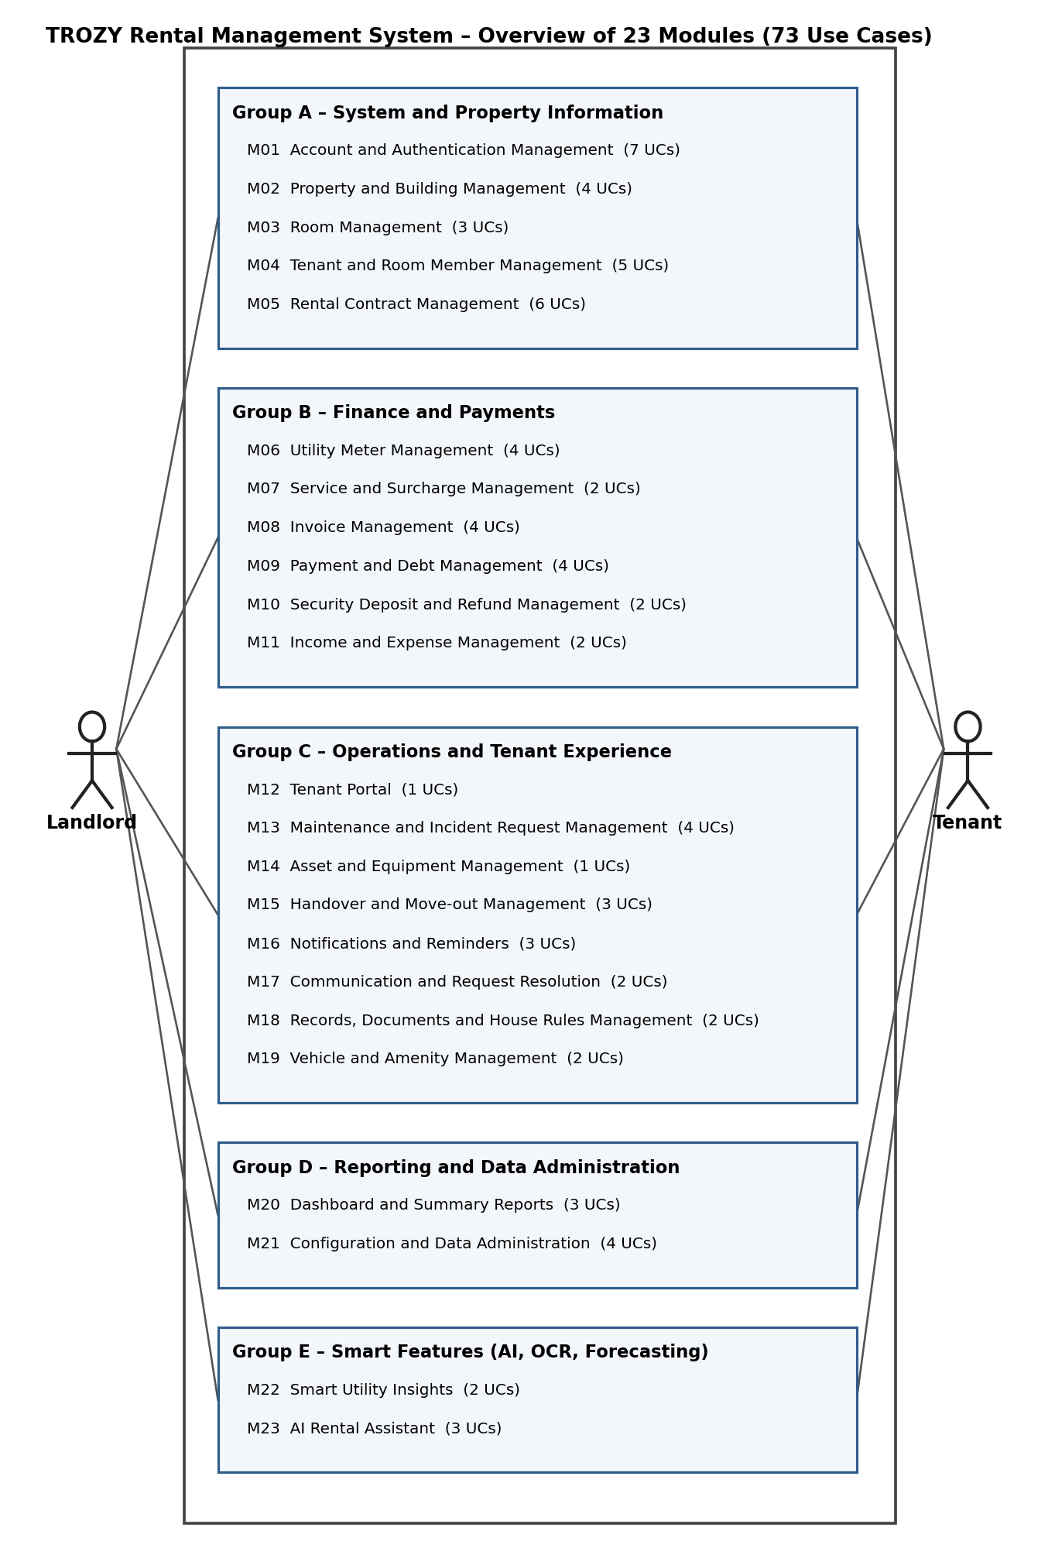

Use-case Diagram: Accounts and Properties (M01–M02)
Figure 2 – Accounts and Properties (M01–M02). Legend: blue ellipses are used by a single actor; yellow ellipses are shared by the Landlord and the Tenant; dashed arrows are include/extend relationships.
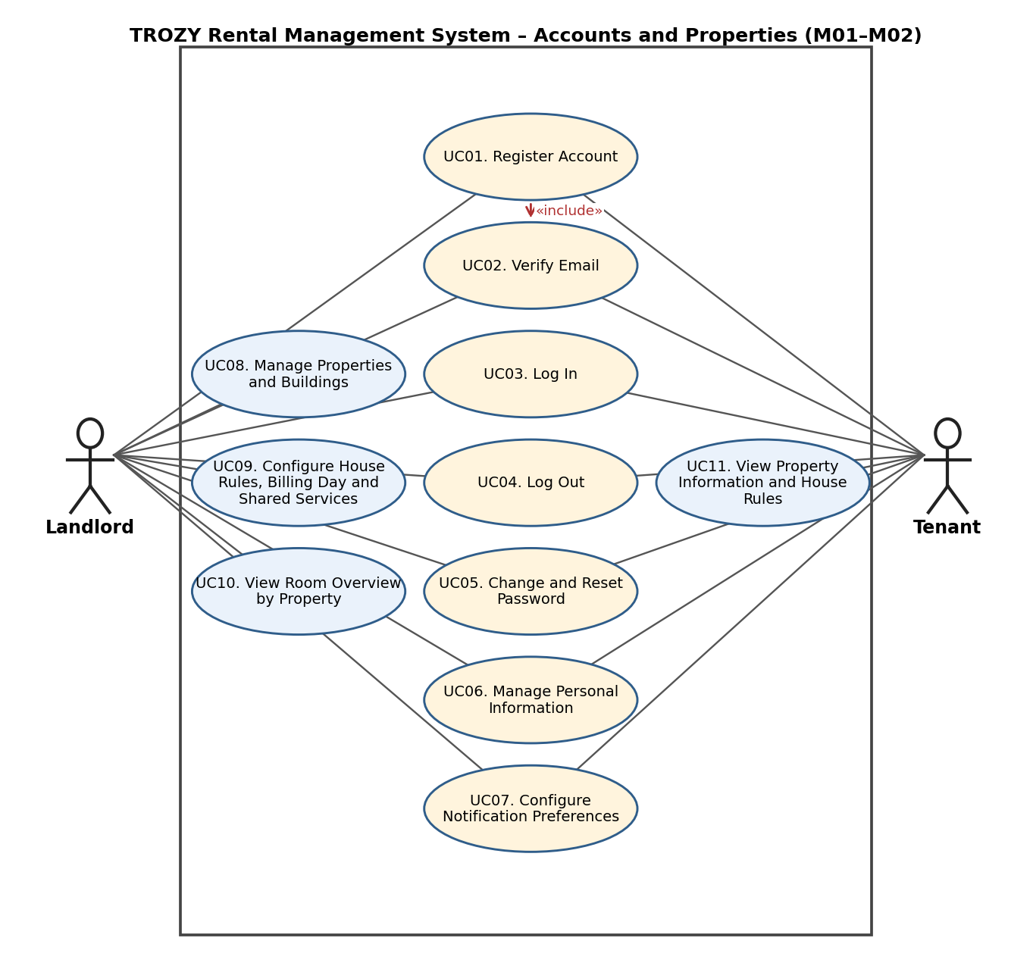

Use-case Diagram: Rooms and Tenants (M03–M04)
Figure 3 – Rooms and Tenants (M03–M04). Legend: blue ellipses are used by a single actor; yellow ellipses are shared by the Landlord and the Tenant; dashed arrows are include/extend relationships.
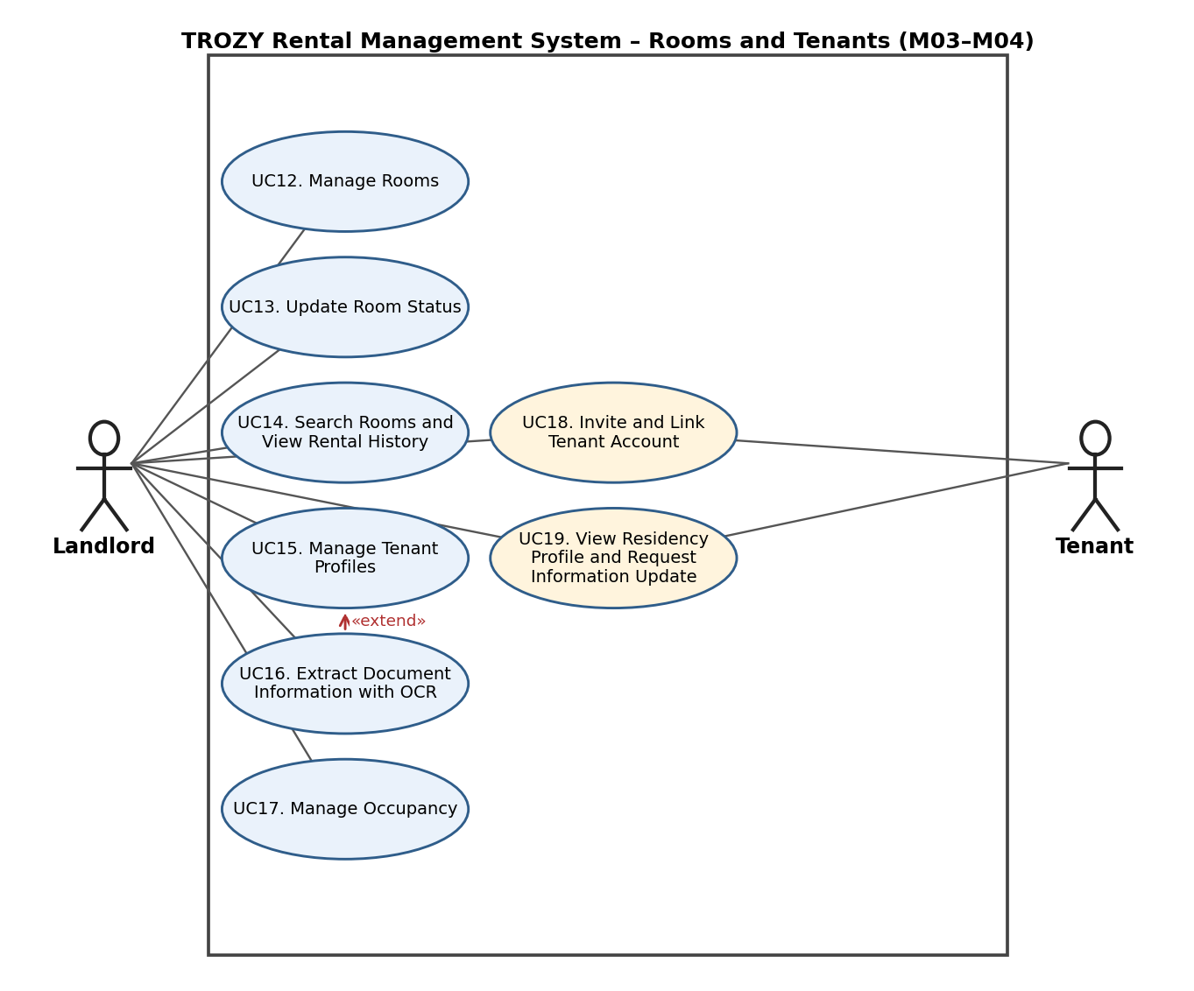

Use-case Diagram: Contracts and Utility Meters (M05–M06)
Figure 4 – Contracts and Utility Meters (M05–M06). Legend: blue ellipses are used by a single actor; yellow ellipses are shared by the Landlord and the Tenant; dashed arrows are include/extend relationships.
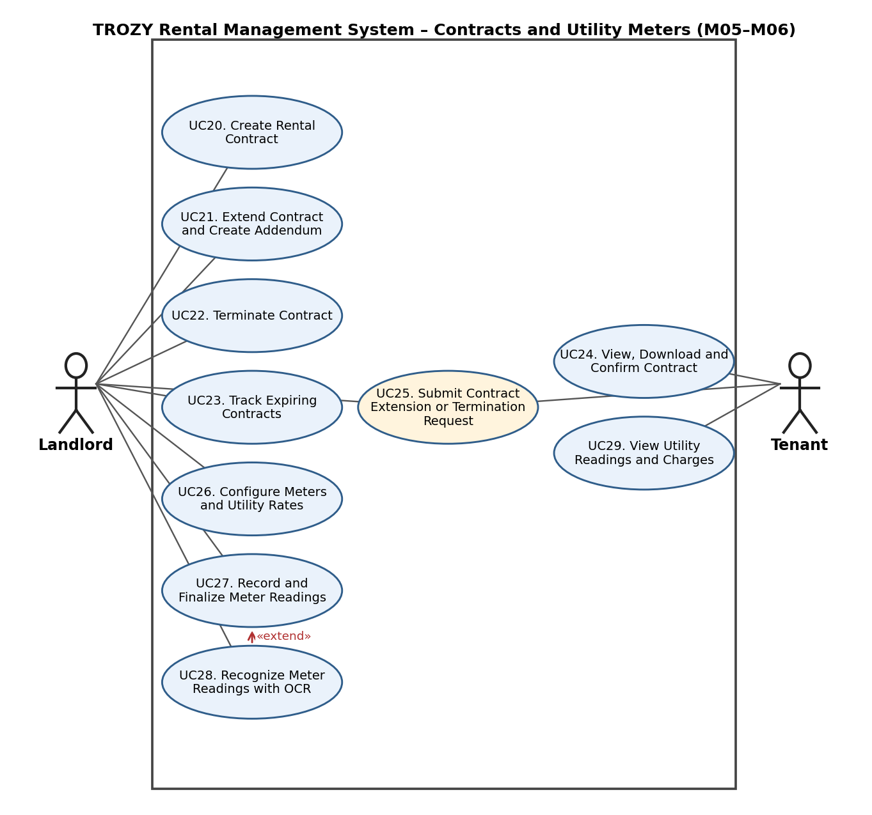

Use-case Diagram: Services, Invoices and Payments (M07–M09)
Figure 5 – Services, Invoices and Payments (M07–M09). Legend: blue ellipses are used by a single actor; yellow ellipses are shared by the Landlord and the Tenant; dashed arrows are include/extend relationships.
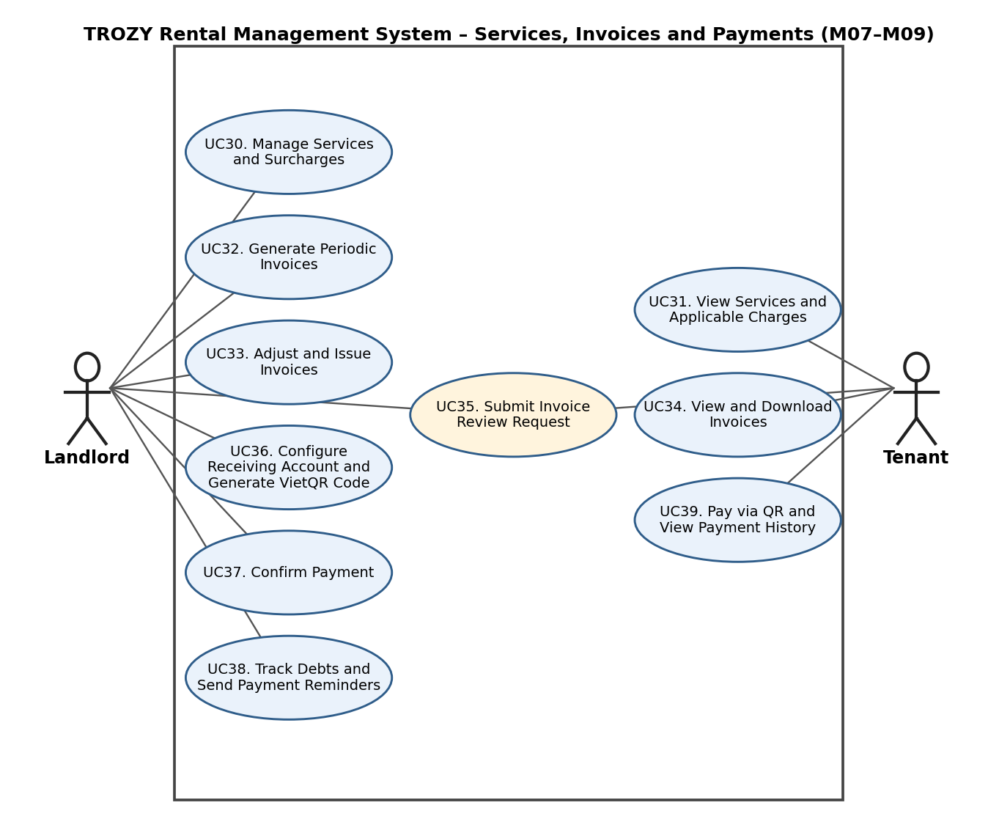

Use-case Diagram: Deposits, Income/Expenses, Tenant Portal and Maintenance (M10–M13)
Figure 6 – Deposits, Income/Expenses, Tenant Portal and Maintenance (M10–M13). Legend: blue ellipses are used by a single actor; yellow ellipses are shared by the Landlord and the Tenant; dashed arrows are include/extend relationships.
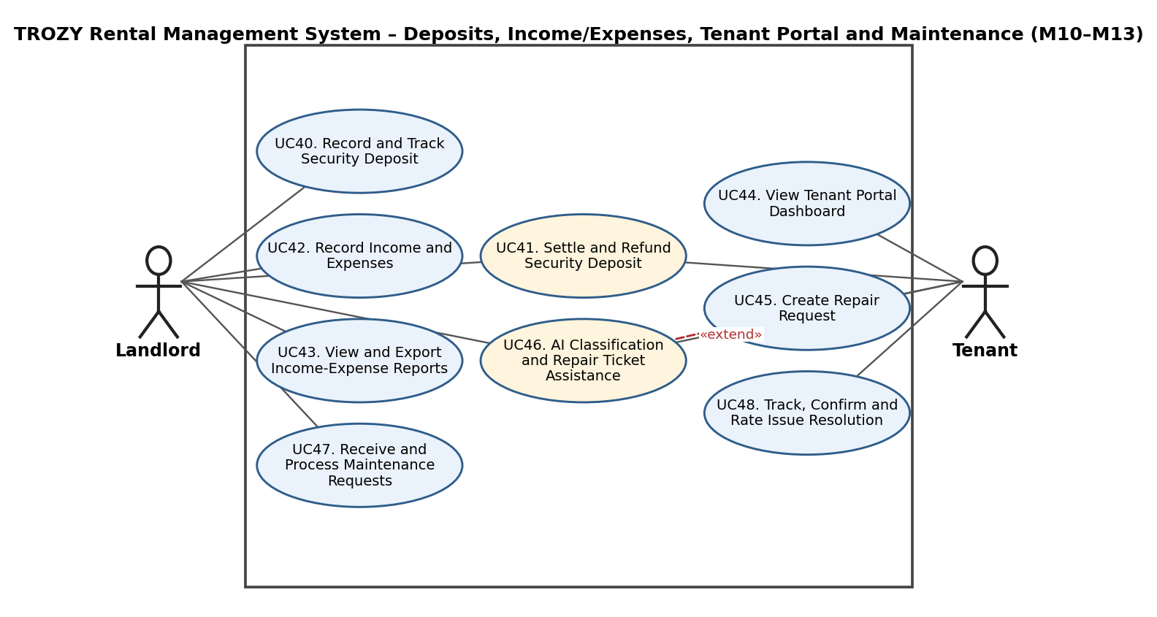

Use-case Diagram: Assets, Handover and Notifications (M14–M16)
Figure 7 – Assets, Handover and Notifications (M14–M16). Legend: blue ellipses are used by a single actor; yellow ellipses are shared by the Landlord and the Tenant; dashed arrows are include/extend relationships.
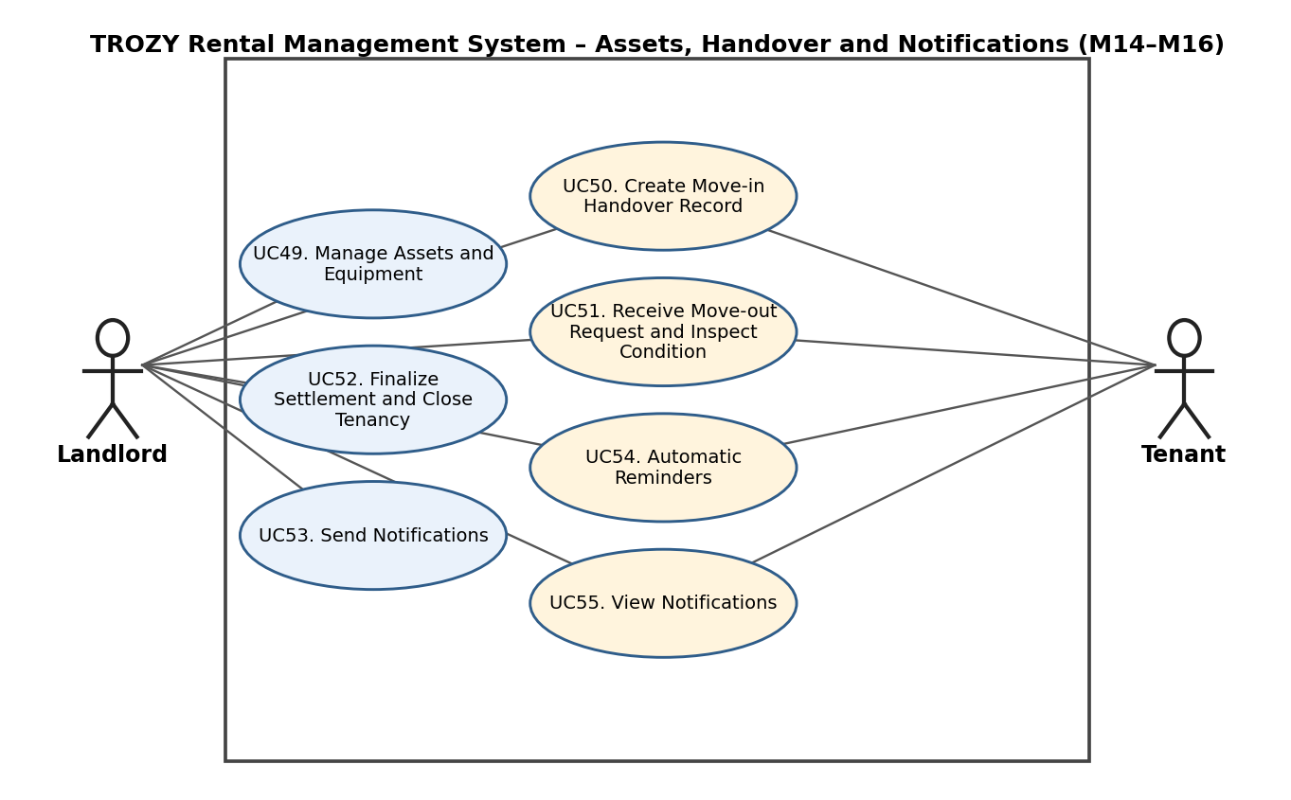

Use-case Diagram: Communication, Documents and Vehicles (M17–M19)
Figure 8 – Communication, Documents and Vehicles (M17–M19). Legend: blue ellipses are used by a single actor; yellow ellipses are shared by the Landlord and the Tenant; dashed arrows are include/extend relationships.
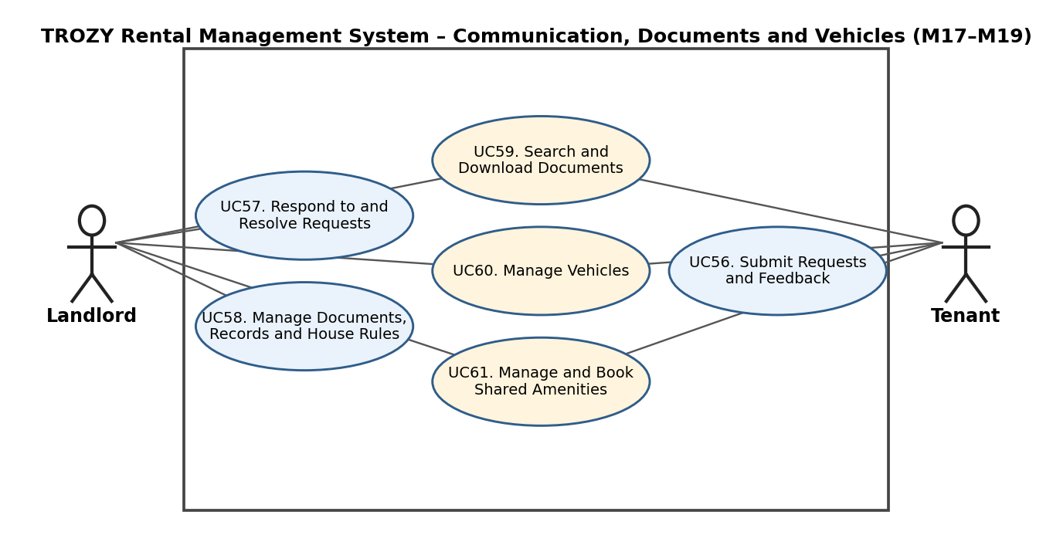

Use-case Diagram: Reports, Configuration, Analytics and AI (M20–M23)
Figure 9 – Reports, Configuration, Analytics and AI (M20–M23). Legend: blue ellipses are used by a single actor; yellow ellipses are shared by the Landlord and the Tenant; dashed arrows are include/extend relationships.
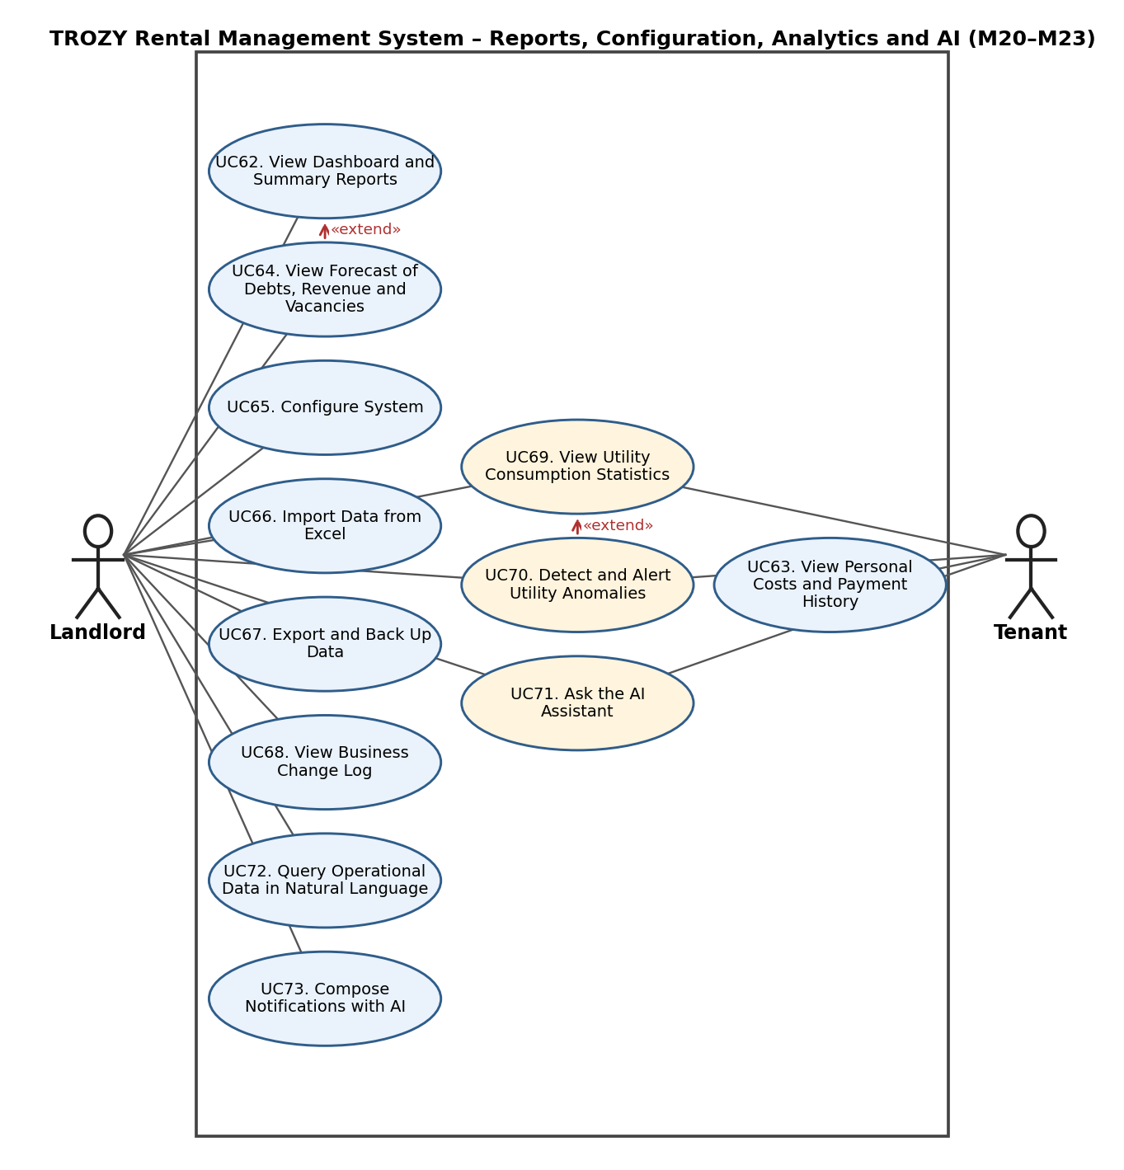

Use-case List
ID | Use case | Actors | Module
UC01 | Register Account | Landlord and Tenant | M01
UC02 | Verify Email | Landlord and Tenant | M01
UC03 | Log In | Landlord and Tenant | M01
UC04 | Log Out | Landlord and Tenant | M01
UC05 | Change and Reset Password | Landlord and Tenant | M01
UC06 | Manage Personal Information | Landlord and Tenant | M01
UC07 | Configure Notification Preferences | Landlord and Tenant | M01
UC08 | Manage Properties and Buildings | Landlord | M02
UC09 | Configure House Rules, Billing Day and Shared Services | Landlord | M02
UC10 | View Room Overview by Property | Landlord | M02
UC11 | View Property Information and House Rules | Tenant | M02
UC12 | Manage Rooms | Landlord | M03
UC13 | Update Room Status | Landlord | M03
UC14 | Search Rooms and View Rental History | Landlord | M03
UC15 | Manage Tenant Profiles | Landlord | M04
UC16 | Extract Document Information with OCR | Landlord | M04
UC17 | Manage Occupancy | Landlord | M04
UC18 | Invite and Link Tenant Account | Landlord and Tenant | M04
UC19 | View Residency Profile and Request Information Update | Tenant and Landlord | M04
UC20 | Create Rental Contract | Landlord | M05
UC21 | Extend Contract and Create Addendum | Landlord | M05
UC22 | Terminate Contract | Landlord | M05
UC23 | Track Expiring Contracts | Landlord | M05
UC24 | View, Download and Confirm Contract | Tenant | M05
UC25 | Submit Contract Extension or Termination Request | Tenant and Landlord | M05
UC26 | Configure Meters and Utility Rates | Landlord | M06
UC27 | Record and Finalize Meter Readings | Landlord | M06
UC28 | Recognize Meter Readings with OCR | Landlord | M06
UC29 | View Utility Readings and Charges | Tenant | M06
UC30 | Manage Services and Surcharges | Landlord | M07
UC31 | View Services and Applicable Charges | Tenant | M07
UC32 | Generate Periodic Invoices | Landlord | M08
UC33 | Adjust and Issue Invoices | Landlord | M08
UC34 | View and Download Invoices | Tenant | M08
UC35 | Submit Invoice Review Request | Tenant and Landlord | M08
UC36 | Configure Receiving Account and Generate VietQR Code | Landlord | M09
UC37 | Confirm Payment | Landlord | M09
UC38 | Track Debts and Send Payment Reminders | Landlord | M09
UC39 | Pay via QR and View Payment History | Tenant | M09
UC40 | Record and Track Security Deposit | Landlord | M10
UC41 | Settle and Refund Security Deposit | Landlord and Tenant | M10
UC42 | Record Income and Expenses | Landlord | M11
UC43 | View and Export Income-Expense Reports | Landlord | M11
UC44 | View Tenant Portal Dashboard | Tenant | M12
UC45 | Create Repair Request | Tenant | M13
UC46 | AI Classification and Repair Ticket Assistance | Tenant and Landlord | M13
UC47 | Receive and Process Maintenance Requests | Landlord | M13
UC48 | Track, Confirm and Rate Issue Resolution | Tenant | M13
UC49 | Manage Assets and Equipment | Landlord | M14
UC50 | Create Move-in Handover Record | Landlord and Tenant | M15
UC51 | Receive Move-out Request and Inspect Condition | Landlord and Tenant | M15
UC52 | Finalize Settlement and Close Tenancy | Landlord | M15
UC53 | Send Notifications | Landlord | M16
UC54 | Automatic Reminders | Landlord and Tenant | M16
UC55 | View Notifications | Landlord and Tenant | M16
UC56 | Submit Requests and Feedback | Tenant | M17
UC57 | Respond to and Resolve Requests | Landlord | M17
UC58 | Manage Documents, Records and House Rules | Landlord | M18
UC59 | Search and Download Documents | Landlord and Tenant | M18
UC60 | Manage Vehicles | Landlord and Tenant | M19
UC61 | Manage and Book Shared Amenities | Landlord and Tenant | M19
UC62 | View Dashboard and Summary Reports | Landlord | M20
UC63 | View Personal Costs and Payment History | Tenant | M20
UC64 | View Forecast of Debts, Revenue and Vacancies  B05 scope: future feature; feasibility research and optional PoC only in the current project; full implementation and integration are not required for Build 3. | Landlord | M20
UC65 | Configure System | Landlord | M21
UC66 | Import Data from Excel | Landlord | M21
UC67 | Export and Back Up Data | Landlord | M21
UC68 | View Business Change Log | Landlord | M21
UC69 | View Utility Consumption Statistics | Landlord and Tenant | M22
UC70 | Detect and Alert Utility Anomalies | Landlord and Tenant | M22
UC71 | Ask the AI Assistant | Landlord and Tenant | M23
UC72 | Query Operational Data in Natural Language | Landlord | M23
UC73 | Compose Notifications with AI | Landlord | M23

Use-case Specifications

Module M01: Account and Authentication Management

Use-case: UC01 – Register Account
Use case Name | Register Account.
Brief description | Allows a Landlord or Tenant to create a new account using an email address in order to use the system.
Actors | Landlord, Tenant
Basic Flow | - The user selects "Register" on the system home page.  - The user selects a role (Landlord or Tenant), enters full name, email, phone number and password, reviews the personal-data processing notice and provides consent to processing the necessary personal data.  - The system validates the data (email format, password strength) and checks that the email is not used by another account.  - The system creates the account with status "Unverified", records the user's consent and sends a verification email.  - The system performs the use case "Verify Email".  - The system notifies the user that registration succeeded and redirects to the login page.
Alternative Flows | Alternative flow 1: Email already exists or data is invalid  - From step 3 of the basic flow, the system shows a specific error at the invalid field.  - The user corrects the data and returns to step 2.  Alternative flow 2: Tenant registers with a link code issued by the Landlord  - From step 2 of the basic flow, the Tenant also enters the link code.  - After the email is verified, the system performs the use case "Invite and Link Tenant Account" to attach the account to the correct profile, room and contract.  - Continue with step 6 of the basic flow.
Pre-conditions | The user has no account and opens the system's registration page.
Post-conditions | The account is created and the verification email has been sent; after verification the user can log in.

Use-case: UC02 – Verify Email
Use case Name | Verify Email.
Brief description | Confirms that the registered email address belongs to the user through a verification link or code. This use case is included by "Register Account".
Actors | Landlord, Tenant
Basic Flow | - The user opens the verification email sent by the system.  - The user clicks the verification link (or enters the verification code).  - The system checks that the link/code is still valid and matches the account.  - The system changes the account status to "Verified".  - The system displays a successful verification message.
Alternative Flows | Alternative flow 1: Link or code has expired  - From step 3 of the basic flow, the system reports that the link has expired.  - The user selects "Resend verification email"; the system sends a new link.  - Return to step 1 of the basic flow.  Alternative flow 2: Email was already verified  - From step 3 of the basic flow, the system reports that the account is already verified and redirects to the login page.
Pre-conditions | The account has been created with status "Unverified".
Post-conditions | The account status becomes "Verified".

Use-case: UC03 – Log In
Use case Name | Log In.
Brief description | Allows a Landlord or Tenant to log in and use the functions according to their role and authorized data scope.
Actors | Landlord, Tenant
Basic Flow | - The user opens the login page.  - The user enters email and password.  - The system checks the credentials and the account status.  - The system creates a login session.  - The system redirects to the interface for the role: the Landlord to the management screen, the Tenant to the tenant portal.
Alternative Flows | Alternative flow 1: Wrong email or password  - From step 3 of the basic flow, the system reports incorrect credentials and lets the user try again.  - If the number of failed attempts exceeds the limit, the system temporarily locks login for a period of time.  Alternative flow 2: Email not verified  - From step 3 of the basic flow, the system refuses login and suggests resending the verification email (use case "Verify Email").
Pre-conditions | The user has a verified account and is not logged in.
Post-conditions | A login session is created; the user can only access data within their own authorization.

Use-case: UC04 – Log Out
Use case Name | Log Out.
Brief description | Ends the current login session or all active login sessions of the user.
Actors | Landlord, Tenant
Basic Flow | - The user selects "Log out".  - The system terminates the current login session.  - The system clears the session information on the client side.  - The system redirects to the login page.
Alternative Flows | Alternative flow 1: Login session expires  - The system automatically terminates the session when its validity period ends.  - The system requires the user to log in again on the next action.  Alternative flow 2: Log out from all devices  - From step 1 of the basic flow, the user selects "Log out from all devices".  - The system terminates all active sessions of the account and continues with step 4.
Pre-conditions | The user is logged in.
Post-conditions | The login session is terminated; the user cannot access functions that require login.

Use-case: UC05 – Change and Reset Password
Use case Name | Change and Reset Password.
Brief description | Allows the user to change the password while logged in, or reset it when forgotten.
Actors | Landlord, Tenant
Basic Flow | - The user selects "Change password" on the personal information page.  - The user enters the current password, the new password and the confirmation of the new password.  - The system checks that the current password is correct, the new password is valid and matches the confirmation.  - The system updates the password and terminates the account's other login sessions.  - The system notifies the user that the password was changed successfully.
Alternative Flows | Alternative flow 1: Forgotten password  - On the login screen, the user selects "Forgot password" and enters the email.  - The system sends a time-limited reset link to the email (a generic message is shown whether or not the email exists).  - The user opens the link and enters a new password as in steps 2 and 3 of the basic flow.  - The system updates the password and requires the user to log in again.  Alternative flow 2: Current password is wrong or the new password is invalid  - From step 3 of the basic flow, the system shows a specific error.  - The user re-enters the data and returns to step 2.
Pre-conditions | Basic flow: the user is logged in. "Forgotten password" flow: the user has an account with a verified email.
Post-conditions | The new password takes effect; the old password can no longer be used.

Use-case: UC06 – Manage Personal Information
Use case Name | Manage Personal Information.
Brief description | Allows the user to view and update personal information, avatar and phone number.
Actors | Landlord, Tenant
Basic Flow | - The user selects "Personal information".  - The system displays the current full name, email, phone number and avatar.  - The user edits the information and/or uploads a new avatar.  - The user selects "Save".  - The system validates the data (phone number format, image format and size).  - The system saves the changes and notifies the user that the update succeeded.
Alternative Flows | Alternative flow 1: Invalid data  - From step 5 of the basic flow, the system shows an error at the invalid field.  - The user corrects it and returns to step 4.  Alternative flow 2: Email change  - From step 5 of the basic flow, if the email changed, the system requires verification of the new email (use case "Verify Email").  - The new email takes effect only after successful verification; continue with step 6 for the remaining information.
Pre-conditions | The user is logged in.
Post-conditions | The user's personal information is updated.

Use-case: UC07 – Configure Notification Preferences
Use case Name | Configure Notification Preferences.
Brief description | Allows the user to choose which notification types and channels (in-app, email) they receive.
Actors | Landlord, Tenant
Basic Flow | - The user selects "Notification settings".  - The system displays the notification types (invoices, contracts, maintenance, support requests, alerts) and the current channels.  - The user turns each notification type on or off for each channel.  - The user selects "Save".  - The system saves the preferences and applies them to notifications sent afterwards.
Alternative Flows | Alternative flow 1: Mandatory notification type  - From step 3 of the basic flow, if the user turns off a mandatory notification type (for example an invoice due notice), the system keeps the in-app channel and explains why.  - Continue with step 4.
Pre-conditions | The user is logged in.
Post-conditions | The user's notification preferences are saved and apply to new notifications.

Module M02: Property and Building Management

Use-case: UC08 – Manage Properties and Buildings
Use case Name | Manage Properties and Buildings.
Brief description | The Landlord adds, edits and archives rental properties and organizes buildings, blocks and floors; one account can manage multiple properties.
Actors | Landlord
Basic Flow | - The Landlord selects "Manage properties".  - The system displays the list of properties under the Landlord's ownership.  - The Landlord selects "Add property" and enters name, address, description and contact information.  - The system checks the required fields and that the property name is unique within the account.  - The system saves the new property.  - The Landlord (if needed) creates buildings, blocks and floors for the property.  - The system saves the structure and displays the updated list.
Alternative Flows | Alternative flow 1: Edit a property or building  - From step 2 of the basic flow, the Landlord selects the property or building to edit and updates the information.  - Return to step 4 to validate and save.  Alternative flow 2: Archive a property  - From step 2 of the basic flow, the Landlord selects "Archive" for a property.  - The system checks that the property has no active contracts.  - The system changes the property to archived status, hides it from the active list and keeps the historical data.  Alternative flow 3: Property still has active contracts  - From step 2 of the "Archive a property" flow, the system refuses to archive and lists the active contracts.
Pre-conditions | The Landlord is logged in.
Post-conditions | The property, building, block and floor are saved; only the owning Landlord can see and manage this data.

Use-case: UC09 – Configure House Rules, Billing Day and Shared Services
Use case Name | Configure House Rules, Billing Day and Shared Services.
Brief description | The Landlord configures house rules, the monthly billing day and shared services for each property.
Actors | Landlord
Basic Flow | - The Landlord selects a property and selects "Operational settings".  - The system displays the property's current house rules, billing day and shared services.  - The Landlord enters or edits the house rules and billing day and selects the shared services that apply.  - The system validates the data (for example the billing day is within the allowed range).  - The system saves the configuration, stores a new version of the house rules and records the change history.
Alternative Flows | Alternative flow 1: Invalid data  - From step 4 of the basic flow, the system shows an error at the invalid field.  - The Landlord corrects it and returns to step 3.  Alternative flow 2: House rules changed  - After step 5 of the basic flow, the system asks the Landlord whether to notify the property's Tenants.  - If yes, the system performs the use case "Send Notifications".
Pre-conditions | The Landlord is logged in and has at least one property.
Post-conditions | The property's house rules, billing day and shared services are updated and the history is stored.

Use-case: UC10 – View Room Overview by Property
Use case Name | View Room Overview by Property.
Brief description | The Landlord views the total rooms, vacant rooms and occupied rooms of each property.
Actors | Landlord
Basic Flow | - The Landlord selects "Property overview".  - The system summarizes total rooms, vacant rooms, rented rooms and rooms awaiting handover for each property under the Landlord's ownership.  - The Landlord selects a property to view details.  - The system displays the property's rooms grouped by status.
Alternative Flows | Alternative flow 1: No property or room yet  - From step 2 of the basic flow, the system shows an empty state and guides the Landlord to create a property and rooms.
Pre-conditions | The Landlord is logged in.
Post-conditions | The Landlord knows the room status of each property; data is not changed.

Use-case: UC11 – View Property Information and House Rules
Use case Name | View Property Information and House Rules.
Brief description | The Tenant views the information and house rules of the property they live in.
Actors | Tenant
Basic Flow | - The Tenant selects "My property".  - The system identifies the property from the Tenant's active contract.  - The system displays the property's name, address, contact information, house rules, shared services and billing day.  - The Tenant views or downloads the house rules.
Alternative Flows | Alternative flow 1: Tenant is not linked to a contract  - From step 2 of the basic flow, the system reports that the account is not linked to a room and guides the Tenant to enter the link code provided by the Landlord.
Pre-conditions | The Tenant is logged in and linked to a contract.
Post-conditions | The Tenant can view the property information under their contract; data is not changed.

Module M03: Room Management

Use-case: UC12 – Manage Rooms
Use case Name | Manage Rooms.
Brief description | The Landlord adds, edits and deactivates rooms and manages room code, area, rent, capacity, amenities and images.
Actors | Landlord
Basic Flow | - The Landlord selects a property and selects "Manage rooms".  - The system displays the property's room list.  - The Landlord selects "Add room" and enters room code, block/floor, area, rent, capacity, amenity list and images.  - The system checks that the room code is unique within the property, rent is greater than 0 and capacity is at least 1.  - The system saves the room with status "Vacant".  - The system displays the new room in the list.
Alternative Flows | Alternative flow 1: Edit room information  - From step 2 of the basic flow, the Landlord selects the room to edit and updates the information.  - If the rent of a room with a contract is changed, the system does not change the current contract; the new rent applies only to new contracts or addenda.  - Return to step 4 to validate and save.  Alternative flow 2: Deactivate a room  - From step 2 of the basic flow, the Landlord selects "Deactivate" for a room.  - The system checks that the room has no active contract.  - The system changes the room to inactive status; if the room is occupied, the system refuses and states the reason.  Alternative flow 3: Duplicate room code or invalid data  - From step 4 of the basic flow, the system shows an error and lets the Landlord correct it; return to step 3.
Pre-conditions | The Landlord is logged in and the property has been created.
Post-conditions | The room information is saved; a new room has status "Vacant".

Use-case: UC13 – Update Room Status
Use case Name | Update Room Status.
Brief description | The Landlord updates the room status along the lifecycle Vacant - Occupied - Awaiting handover - Vacant, and the maintenance status. Some status changes are performed automatically by the system when a contract is created, a tenant moves out or a handover is completed.
Actors | Landlord
Basic Flow | - The Landlord opens a room's details.  - The system displays the current status and the statuses that may be changed to.  - The Landlord selects the new status (for example "Maintenance" or "Reopen") and enters a reason.  - The system checks the status transition rules and ensures a room never has overlapping contracts.  - The system saves the new status and records the change history.
Alternative Flows | Alternative flow 1: Occupied room moved to maintenance  - From step 4 of the basic flow, the system only blocks new tenants from being accepted, keeps the current contract unchanged and continues with step 5.  Alternative flow 2: Invalid status transition  - From step 4 of the basic flow, the system refuses and states the rule that was violated.  - The Landlord selects another status and returns to step 3.
Pre-conditions | The Landlord is logged in and the room belongs to the Landlord's property.
Post-conditions | The room status is updated and the change history is stored.

Use-case: UC14 – Search Rooms and View Rental History
Use case Name | Search Rooms and View Rental History.
Brief description | The Landlord filters rooms by property, floor, status and price and views each room's tenant and contract history.
Actors | Landlord
Basic Flow | - The Landlord opens the room list.  - The Landlord selects filter criteria: property, floor, status, price range.  - The system displays the rooms that match the criteria.  - The Landlord selects a room.  - The system displays the room information with its tenant and contract history over time.
Alternative Flows | Alternative flow 1: No room matches the criteria  - From step 3 of the basic flow, the system reports no results and lets the Landlord change the filters.
Pre-conditions | The Landlord is logged in.
Post-conditions | The Landlord can view room information and rental history; data is not changed.

Module M04: Tenant and Room Member Management

Use-case: UC15 – Manage Tenant Profiles
Use case Name | Manage Tenant Profiles.
Brief description | The Landlord creates and updates profiles of tenants and room members, including tenants who do not yet have an account.
Actors | Landlord
Basic Flow | - The Landlord selects "Tenants" and selects "Add profile".  - The Landlord records the main tenant's consent to processing necessary personal data and enters the tenant's information (full name, date of birth, phone number, email, identity document information required for residency records).  - The Landlord adds co-occupants of the room (if any) and records each co-occupant's consent to processing their necessary personal data.  - The system validates the data and warns if the document number or phone number already exists.  - The system saves the profile with status "No account" and stores the recorded consent.  - The system displays the profile in the tenant list.
Alternative Flows | Alternative flow 1: Edit a profile  - From step 1 of the basic flow, the Landlord selects a profile and updates the information.  - The system saves the changes with history and continues with step 4.  Alternative flow 2: Possible duplicate profile  - From step 4 of the basic flow, the system displays the existing profile.  - The Landlord chooses to use the existing profile or confirms creating a new one.  Alternative flow 3: Enter information from a document image  - From step 2 of the basic flow, the Landlord selects "Enter from document image".  - The system performs the use case "Extract Document Information with OCR" and fills the form; continue with step 3.
Pre-conditions | The Landlord is logged in.
Post-conditions | The tenant profile is saved; personal data can only be accessed according to authorization.

Use-case: UC16 – Extract Document Information with OCR
Use case Name | Extract Document Information with OCR.
Brief description | The Landlord uploads an image of an identity card or a paper contract; the system extracts structured data for the Landlord to verify before use. This use case extends "Manage Tenant Profiles". Identity-card images are used only for temporary OCR processing and are not retained, including after failed or cancelled processing.
Actors | Landlord
Basic Flow | - The Landlord uploads or captures an image of the document.  - The system checks the image format and size and sends the image to the OCR service.  - The system extracts the information (full name, document number, date of birth, address, or the main contract terms).  - The system displays the extraction result next to the original image for the Landlord to compare and edit.  - The Landlord confirms the result.  - The system fills the confirmed data into the profile/contract form, discards the temporary identity-card image and may store paper-contract images according to authorization.
Alternative Flows | Alternative flow 1: Image is blurred or unreadable  - From step 3 of the basic flow, the system reports that extraction failed.  - The Landlord captures a new image (return to step 1) or enters the information manually.  Alternative flow 2: Landlord does not accept the result  - From step 5 of the basic flow, the Landlord discards the result and enters the information manually.  - The system deletes the temporary OCR result and discards any temporary identity-card image.
Pre-conditions | The Landlord is logged in and working on a tenant profile or a contract.
Post-conditions | OCR data is saved only after the Landlord confirms it.

Use-case: UC17 – Manage Occupancy
Use case Name | Manage Occupancy.
Brief description | The Landlord records move-in, move-out and room-transfer dates of tenants and members, and tracks whether they are currently renting or have left.
Actors | Landlord
Basic Flow | - The Landlord selects a tenant or member profile.  - The Landlord selects "Record move-in", selects the room and enters the move-in date.  - The system checks that the room has remaining capacity and an active contract.  - The system saves the occupancy information and sets the status "Currently renting".  - The system updates the tenant's occupancy history.
Alternative Flows | Alternative flow 1: Move-out  - From step 1 of the basic flow, the Landlord selects "Record move-out" and enters the move-out date.  - The system sets the status "Left" and stores the history.  - If this is the last main tenant of the room, the system suggests starting the move-out procedure.  Alternative flow 2: Room transfer  - From step 1 of the basic flow, the Landlord selects "Transfer room" and selects a new vacant room.  - The system checks the new room, records the transfer history and updates the status of both rooms.  Alternative flow 3: Room capacity exceeded  - From step 3 of the basic flow, the system refuses and states the room's maximum capacity.
Pre-conditions | The Landlord is logged in; the tenant profile and the room exist.
Post-conditions | Occupancy information and the move-in, move-out and room-transfer history are updated.

Use-case: UC18 – Invite and Link Tenant Account
Use case Name | Invite and Link Tenant Account.
Brief description | The Landlord creates an invitation or link code so that a Tenant without an account can connect to the correct profile, room and contract.
Actors | Landlord, Tenant
Basic Flow | - The Landlord opens the profile of a tenant without an account and selects "Send invitation".  - The system creates a time-limited link code tied to the Tenant's profile, room and contract.  - The system sends the invitation by email or displays the code for the Landlord to pass to the Tenant.  - The Tenant registers an account (or logs in) and enters the link code or opens the invitation link.  - The system checks that the code is valid, not expired and not yet used.  - The system links the Tenant's account to the correct profile, room and contract.  - The system notifies both the Landlord and the Tenant of the result.
Alternative Flows | Alternative flow 1: Code expired or already used  - From step 5 of the basic flow, the system refuses and reports that the code is invalid.  - The Landlord revokes the old code and creates a new one, returning to step 2.  Alternative flow 2: Account email differs from the email in the profile  - From step 5 of the basic flow, the system asks the Landlord to confirm before linking.  - If the Landlord confirms, continue with step 6; if the Landlord refuses, the system cancels the link request.
Pre-conditions | The Landlord has created the tenant profile; the Tenant has or is registering an account.
Post-conditions | The Tenant's account is linked to the correct profile, room and contract; the Tenant can access the portal.

Use-case: UC19 – View Residency Profile and Request Information Update
Use case Name | View Residency Profile and Request Information Update.
Brief description | The Tenant views their personal profile, occupancy information and the list of co-occupants within the permitted scope, and submits a request to update information when it is wrong.
Actors | Tenant, Landlord
Basic Flow | - The Tenant selects "My profile".  - The system displays personal information, occupancy information (room, move-in date, status) and the list of co-occupants the Tenant is allowed to see.  - The Tenant notices incorrect information and selects "Request update".  - The Tenant enters the content to be updated and submits.  - The system creates a request with status "Pending" and notifies the Landlord.  - The Landlord reviews, approves and updates the profile.  - The system notifies the Tenant of the result.
Alternative Flows | Alternative flow 1: Landlord rejects the request  - From step 6 of the basic flow, the Landlord enters a rejection reason.  - The system notifies the Tenant of the reason and closes the request.  Alternative flow 2: Tenant only views the information  - From step 3 of the basic flow, the Tenant does not submit a request; the use case ends.
Pre-conditions | The Tenant is logged in and linked to a profile.
Post-conditions | The Tenant can view their profile; if a request is approved, the profile is updated.

Module M05: Rental Contract Management

Use-case: UC20 – Create Rental Contract
Use case Name | Create Rental Contract.
Brief description | The Landlord creates a rental contract from a template and records rent, security deposit, term and conditions.
Actors | Landlord
Basic Flow | - The Landlord selects a vacant room and a tenant profile, then selects "Create contract".  - The Landlord selects a contract template.  - The Landlord enters rent, security deposit, start date, end date, billing day and terms.  - The system validates the data and ensures the room has no other contract overlapping in time.  - The system generates a preview (PDF) of the contract.  - The Landlord confirms saving the contract.  - The system saves the contract (version 1), records the security deposit, notifies the Tenant and sets the room status to "Occupied" when the contract takes effect.
Alternative Flows | Alternative flow 1: Contract overlaps in time  - From step 4 of the basic flow, the system refuses and displays the conflicting contract.  - The Landlord changes the room or the dates and returns to step 3.  Alternative flow 2: Save a draft contract  - From step 6 of the basic flow, the Landlord selects "Save draft".  - The system saves the contract as a draft, not yet effective, and does not change the room status.  Alternative flow 3: No tenant profile yet  - From step 1 of the basic flow, the Landlord performs the use case "Manage Tenant Profiles" to create a profile and then continues.
Pre-conditions | The Landlord is logged in; the room is vacant and the tenant profile exists (or will be created).
Post-conditions | The contract is saved with its PDF and version history; the room becomes "Occupied" when the contract takes effect.

Use-case: UC21 – Extend Contract and Create Addendum
Use case Name | Extend Contract and Create Addendum.
Brief description | The Landlord extends a contract or records an addendum when rent or terms change, keeping the previous versions.
Actors | Landlord
Basic Flow | - The Landlord opens an active or soon-to-expire contract.  - The Landlord selects "Extend" or "Create addendum".  - The Landlord enters the new end date and/or the changed rent or terms and the effective date.  - The system validates the data and ensures there is no overlap with another contract of the room.  - The system creates the addendum/new version and keeps the old version in the history.  - The Landlord confirms.  - The system saves, updates the term and rent from the effective date and notifies the Tenant.
Alternative Flows | Alternative flow 1: Handle an extension request submitted by the Tenant  - From step 1 of the basic flow, the Landlord opens the Tenant's extension request.  - If approved, the system loads the data from the request and continues with step 4.  - If rejected, the Landlord enters a reason; the system notifies the Tenant and the use case ends.  Alternative flow 2: Rent change effective mid-period  - From step 4 of the basic flow, the system warns about how the invoice of that period will be calculated.  - The Landlord confirms and continues with step 5.
Pre-conditions | The Landlord is logged in; the contract is active.
Post-conditions | The addendum or new version is saved and takes effect; the Tenant is notified.

Use-case: UC22 – Terminate Contract
Use case Name | Terminate Contract.
Brief description | The Landlord records the termination of a contract (expiry or early termination) and starts the move-out procedure.
Actors | Landlord
Basic Flow | - The Landlord opens the contract to terminate and selects "Terminate contract".  - The Landlord enters the end date and the termination reason.  - The system checks that the contract is active and the end date is valid.  - The system changes the contract to status "Terminating" and creates the move-out record.  - The system changes the room status to "Awaiting handover" and notifies the Tenant.
Alternative Flows | Alternative flow 1: Termination requested by the Tenant  - From step 1 of the basic flow, the Landlord opens the Tenant's termination request.  - The Landlord confirms the end date as requested and continues with step 3.  Alternative flow 2: Contract is no longer active  - From step 3 of the basic flow, the system refuses and reports the current status of the contract.
Pre-conditions | The Landlord is logged in; the contract is active.
Post-conditions | The contract is "Terminating"; the move-out record is created; the contract becomes "Ended" only after move-out and settlement are completed.

Use-case: UC23 – Track Expiring Contracts
Use case Name | Track Expiring Contracts.
Brief description | The Landlord views the list of soon-to-expire contracts in order to extend or terminate them proactively.
Actors | Landlord
Basic Flow | - The Landlord selects "Expiring contracts".  - The system lists the contracts that will expire within the configured threshold, sorted by expiry date.  - The Landlord selects a contract.  - The system displays the contract details and the actions: extend, terminate, remind Tenant.  - The Landlord selects the appropriate action.
Alternative Flows | Alternative flow 1: No expiring contracts  - From step 2 of the basic flow, the system displays an empty list.  Alternative flow 2: Landlord chooses to remind the Tenant  - From step 5 of the basic flow, the system performs the use case "Send Notifications" to the Tenant of the contract.
Pre-conditions | The Landlord is logged in.
Post-conditions | The Landlord knows which contracts are expiring and can take the next action.

Use-case: UC24 – View, Download and Confirm Contract
Use case Name | View, Download and Confirm Contract.
Brief description | The Tenant views and downloads their contract and addenda and confirms having read or agreed to the terms.
Actors | Tenant
Basic Flow | - The Tenant selects "My contract".  - The system displays the active contract (rent, security deposit, term, terms, addenda, version history).  - The Tenant views the content and downloads the PDF.  - The Tenant selects "Confirm read and agreed".  - The system records the confirmation (account, time) and notifies the Landlord.
Alternative Flows | Alternative flow 1: A new addendum or version exists  - From step 2 of the basic flow, the system highlights the new content and requires the Tenant to confirm again.  Alternative flow 2: Tenant does not agree with the content  - From step 3 of the basic flow, the Tenant does not confirm and sends feedback through the use case "Submit Requests and Feedback".
Pre-conditions | The Tenant is logged in and has a contract linked to the account.
Post-conditions | The Tenant's confirmation is stored. Note: confirmation on the web is not automatically equivalent to a legally valid electronic signature.

Use-case: UC25 – Submit Contract Extension or Termination Request
Use case Name | Submit Contract Extension or Termination Request.
Brief description | The Tenant submits a request to extend or end the contract to the Landlord and tracks the result.
Actors | Tenant, Landlord
Basic Flow | - The Tenant opens the active contract.  - The Tenant selects "Request extension" or "Request termination".  - The Tenant enters the desired term or the expected end date and a reason.  - The system validates the data and that the request is submitted at a valid time.  - The system creates the request with status "Pending" and notifies the Landlord.  - The Landlord processes the request (use case "Extend Contract and Create Addendum" or "Terminate Contract").  - The system notifies the Tenant of the result.
Alternative Flows | Alternative flow 1: A request is already pending  - From step 4 of the basic flow, the system does not create a new request, displays the existing request and lets the Tenant cancel it.  Alternative flow 2: Tenant cancels the request  - While the request is still "Pending", the Tenant selects "Cancel request".  - The system closes the request and notifies the Landlord.
Pre-conditions | The Tenant is logged in and has an active contract.
Post-conditions | The request is recorded and the Landlord is notified; the Tenant can track its status.

Module M06: Utility Meter Management

Use-case: UC26 – Configure Meters and Utility Rates
Use case Name | Configure Meters and Utility Rates.
Brief description | The Landlord registers electricity and water meters for each room, selects the calculation method and sets electricity and water rates.
Actors | Landlord
Basic Flow | - The Landlord selects a property or room and selects "Utilities".  - The Landlord adds an electricity/water meter for the room (meter code, initial reading).  - The Landlord selects the calculation method (by meter, per person or fixed fee).  - The Landlord enters the electricity rate, the water rate and the effective start date.  - The system validates the data (rates are not negative, the initial reading is not negative).  - The system saves the configuration and records the rate change history.
Alternative Flows | Alternative flow 1: Replace a meter  - From step 2 of the basic flow, the Landlord selects "Replace meter" and enters the final reading of the old meter and the initial reading of the new meter.  - The system stores the history so that the consumption of the period with the replacement is not miscalculated.  Alternative flow 2: Invalid data  - From step 5 of the basic flow, the system shows an error at the invalid field; the Landlord corrects it and returns to step 4.
Pre-conditions | The Landlord is logged in; the room has been created.
Post-conditions | The meters, calculation method and rates are saved with change history.

Use-case: UC27 – Record and Finalize Meter Readings
Use case Name | Record and Finalize Meter Readings.
Brief description | The Landlord records opening/closing readings with meter photos; the system calculates consumption and amounts; after review, the Landlord finalizes the readings for invoicing.
Actors | Landlord
Basic Flow | - The Landlord selects the property and the billing period.  - The system displays the room list with the previous period's closing readings.  - The Landlord enters the new readings and uploads meter photos for each room.  - The system checks that the new reading is not lower than the old reading and calculates consumption and amount using the rates.  - The system saves the readings with the recorder and recording time.  - The Landlord reviews and selects "Finalize readings".  - The system locks the period's readings and passes them to the invoicing data.
Alternative Flows | Alternative flow 1: New reading lower than old reading  - From step 4 of the basic flow, the system shows an error.  - The Landlord corrects the reading or confirms it is a meter replacement case; return to step 3.  Alternative flow 2: Enter readings by photo (OCR)  - From step 3 of the basic flow, the Landlord selects "Scan meter photo".  - The system performs the use case "Recognize Meter Readings with OCR" and fills in the reading confirmed by the Landlord; continue with step 4.  Alternative flow 3: Edit finalized readings  - After step 7 of the basic flow, the Landlord unlocks the finalized period and enters a reason for the edit.  - The system stores the edit history; if the invoice for that period has been issued, the Landlord creates an adjustment invoice (use case "Adjust and Issue Invoices").  Alternative flow 4: Readings look abnormal  - After step 4 of the basic flow, the system performs the use case "Detect and Alert Utility Anomalies" and displays an alert for the Landlord to check before finalizing.
Pre-conditions | The Landlord is logged in; meters and rates have been configured.
Post-conditions | The period's readings are saved and finalized, ready for invoicing.

Use-case: UC28 – Recognize Meter Readings with OCR
Use case Name | Recognize Meter Readings with OCR.
Brief description | The Landlord photographs the electricity/water meter; the system extracts the reading, compares it with the previous period and proposes the number to enter. This use case extends "Record and Finalize Meter Readings"; Tenants cannot edit meter readings.
Actors | Landlord
Basic Flow | - The Landlord selects "Scan meter photo" for a room and captures or uploads a photo.  - The system checks the photo quality and, if acceptable, runs OCR to read the value on the photo.  - The system compares it with the previous period's reading and proposes the reading to enter.  - The Landlord checks the photo and the proposed number.  - The Landlord confirms or edits the reading.  - The system fills the reading into the input field and stores the photo as evidence.
Alternative Flows | Alternative flow 1: Photo quality is insufficient, OCR cannot read or confidence is low  - From step 2 of the basic flow, the system reports it and asks the Landlord to recapture or enter the value manually.  - Return to step 1 or end the use case if the Landlord enters manually.  Alternative flow 2: Recognized reading is lower than the previous period  - From step 3 of the basic flow, the system warns and requires the Landlord to re-check before confirming.
Pre-conditions | The Landlord is logged in and is recording readings of a period that is not yet finalized.
Post-conditions | The reading is used for billing only after the Landlord confirms and finalizes it.

Use-case: UC29 – View Utility Readings and Charges
Use case Name | View Utility Readings and Charges.
Brief description | The Tenant views the readings, meter photos, rates, consumption and amount payable for their room.
Actors | Tenant
Basic Flow | - The Tenant selects "Utilities".  - The Tenant selects the period to view.  - The system displays the opening/closing readings, meter photos, rates, consumption and amount of the selected period.  - The Tenant views the history of previous periods.
Alternative Flows | Alternative flow 1: Period not yet finalized  - From step 3 of the basic flow, the system displays the status "Readings not finalized" and does not show the amount.
Pre-conditions | The Tenant is logged in and has a linked contract.
Post-conditions | The Tenant can view the utility data of their room; data is not changed.

Module M07: Service and Surcharge Management

Use-case: UC30 – Manage Services and Surcharges
Use case Name | Manage Services and Surcharges.
Brief description | The Landlord creates services (Internet, cleaning, garbage, parking, management fee, etc.), configures rates, applies them to rooms or contracts, and adds extra charges or deductions.
Actors | Landlord
Basic Flow | - The Landlord selects "Services".  - The Landlord selects "Add service" and enters the service name, calculation method (per room, person, vehicle or month) and rate.  - The system validates the data and saves the service with its rate history.  - The Landlord selects the rooms or contracts the service applies to (if it is a specific service).  - The system saves the assignment and displays the room's service list.
Alternative Flows | Alternative flow 1: Edit a service rate  - From step 1 of the basic flow, the Landlord selects a service and enters the new rate and the period from which it applies.  - The system stores the rate change history; finalized periods are not affected.  Alternative flow 2: Add an extra charge or deduction  - From step 1 of the basic flow, the Landlord selects a room and period and enters the extra charge or deduction with a reason.  - The system saves it to be included in the invoice of the corresponding period.  Alternative flow 3: Discontinue a service  - From step 1 of the basic flow, the Landlord selects "Discontinue service".  - The system stops applying it from the next period and keeps the data of previous periods.
Pre-conditions | The Landlord is logged in.
Post-conditions | The services, rates, assignments and extra charges/deductions are saved with history.

Use-case: UC31 – View Services and Applicable Charges
Use case Name | View Services and Applicable Charges.
Brief description | The Tenant views the list of services and the charges that apply to their room.
Actors | Tenant
Basic Flow | - The Tenant selects "Services".  - The system displays the services applied to the room (name, calculation method, rate, quantity).  - The system displays the extra charges or deductions of the current period (if any).  - The Tenant views the price change history of a service.
Alternative Flows | Alternative flow 1: Room has no services applied  - From step 2 of the basic flow, the system displays an empty list.
Pre-conditions | The Tenant is logged in and has a linked contract.
Post-conditions | The Tenant can view the services and charges of their room; data is not changed.

Module M08: Invoice Management

Use-case: UC32 – Generate Periodic Invoices
Use case Name | Generate Periodic Invoices.
Brief description | The system generates draft invoices for the period by aggregating rent, electricity, water, services and extra charges; the Landlord can also trigger it manually.
Actors | Landlord
Basic Flow | - When the billing period arrives per the configuration (or the Landlord selects "Generate period invoices"), the system starts generating invoices.  - The system checks that the period's utility readings have been finalized for meter-based charges; per-person or fixed-fee charges do not require meter readings.  - The system checks that no periodic invoice already exists for the same subject and billing period.  - The system aggregates rent, electricity, water, services, extra charges and deductions.  - The system creates the invoice with status Draft.  - The system displays the list of draft invoices to the Landlord.
Alternative Flows | Alternative flow 1: Some rooms lack required finalized readings  - From step 2 of the basic flow, the system lists the rooms that are missing readings required for meter-based charges.  - The system generates invoices only for rooms with sufficient data; continue with step 3.  Alternative flow 2: Periodic invoice already exists  - From step 3 of the basic flow, the system refuses to create a duplicate and suggests using an adjustment invoice.  Alternative flow 3: Generate an invoice for one room  - From step 1 of the basic flow, the Landlord selects a specific room and period; the system performs steps 2 to 6 for that room.
Pre-conditions | The Landlord has contracts, rates and, for meter-based utility charges, finalized utility readings for the period.
Post-conditions | Draft invoices are created; there are no two periodic invoices for the same subject and period.

Use-case: UC33 – Adjust and Issue Invoices
Use case Name | Adjust and Issue Invoices.
Brief description | The Landlord previews and adjusts a draft invoice, issues it and notifies the Tenant; supports PDF export, printing and creating adjustment invoices with history.
Actors | Landlord
Basic Flow | - The Landlord opens a draft invoice.  - The system displays the details of each charge and the calculation formula.  - The Landlord edits the lines (adds or reduces items, notes) if needed.  - The system recalculates the total.  - The Landlord selects "Issue".  - The system changes the invoice to status "Unpaid", sets the due date and locks the content.  - The system performs the use case "Send Notifications" to the Tenant.
Alternative Flows | Alternative flow 1: Adjust an issued invoice  - The Landlord opens the issued invoice and selects "Create adjustment invoice", entering the reason and content.  - The system creates the adjustment, keeps the history and notifies the Tenant.  Alternative flow 2: Export PDF or print the invoice  - After step 6 of the basic flow, the Landlord selects "Export PDF" or "Print"; the system generates the invoice file.  Alternative flow 3: Delete a draft invoice  - From step 1 of the basic flow, the Landlord selects "Delete draft"; the system allows this only for invoices that have not been issued.
Pre-conditions | The Landlord is logged in; the draft invoice has been created.
Post-conditions | The invoice is issued and the Tenant is notified; every adjustment has history.

Use-case: UC34 – View and Download Invoices
Use case Name | View and Download Invoices.
Brief description | The Tenant views invoice details, due date, calculation formula and adjustment history, and downloads invoices.
Actors | Tenant
Basic Flow | - The Tenant selects "Invoices".  - The system displays the room's invoice list (newest first) with status.  - The Tenant selects an invoice.  - The system displays rent, electricity, water, services, due date, calculation formula and adjustment history.  - The Tenant downloads the invoice as a PDF.
Alternative Flows | Alternative flow 1: No invoices yet  - From step 2 of the basic flow, the system displays an empty list.
Pre-conditions | The Tenant is logged in; the Landlord has issued invoices.
Post-conditions | The Tenant can view their invoices; data is not changed.

Use-case: UC35 – Submit Invoice Review Request
Use case Name | Submit Invoice Review Request.
Brief description | The Tenant requests a review when they find an error on an invoice; the Landlord reviews and responds or creates an adjustment invoice.
Actors | Tenant, Landlord
Basic Flow | - The Tenant opens an invoice and selects "Request review".  - The Tenant selects the disputed item, enters a description and attaches photos (if any).  - The system creates a request of type "Invoice review" linked to the invoice and notifies the Landlord.  - The Landlord checks the related data (meter readings, services, payments).  - The Landlord responds through the use case "Respond to and Resolve Requests".  - The system notifies the Tenant of the result.
Alternative Flows | Alternative flow 1: Invoice is wrong  - From step 4 of the basic flow, the Landlord creates an adjustment invoice (use case "Adjust and Issue Invoices").  - Continue with step 5.  Alternative flow 2: Invoice is correct  - From step 4 of the basic flow, the Landlord replies with an explanation based on the data and closes the request.
Pre-conditions | The Tenant is logged in and the invoice has been issued.
Post-conditions | The review request is recorded, processed and its communication history is stored.

Module M09: Payment and Debt Management

Use-case: UC36 – Configure Receiving Account and Generate VietQR Code
Use case Name | Configure Receiving Account and Generate VietQR Code.
Brief description | The Landlord configures the receiving bank account; the system generates a VietQR code according to the amount and payment content of each invoice.
Actors | Landlord
Basic Flow | - The Landlord selects "Payments".  - The Landlord enters the receiving account information (bank, account number, account holder) for the property.  - The system validates the data and saves the configuration.  - When an invoice is issued or the Tenant opens an invoice to pay, the system generates a VietQR code with the remaining amount and the transfer content (invoice/room code).  - The system displays the VietQR code on the invoice.
Alternative Flows | Alternative flow 1: Receiving account not configured  - From step 4 of the basic flow, the system does not display the QR code and notifies the Landlord to configure the account.  Alternative flow 2: Update the receiving account  - From step 2 of the basic flow, the Landlord edits the account information; the change applies to QR codes generated afterwards.
Pre-conditions | The Landlord is logged in.
Post-conditions | The receiving account is saved; the VietQR code is generated with the correct amount and content. The QR code only supports bank transfers and does not confirm payment by itself.

Use-case: UC37 – Confirm Payment
Use case Name | Confirm Payment.
Brief description | The Landlord records cash or bank-transfer payments, confirms receipt of money, tracks partial payments or overpayments and issues receipts.
Actors | Landlord
Basic Flow | - The Landlord opens an unpaid or partially paid invoice.  - The Landlord selects "Record payment" and selects the method (cash or bank transfer).  - The Landlord enters the amount, date received and notes.  - The system checks that the amount is greater than 0.  - The Landlord confirms that the money has been received.  - The system updates the invoice status and the remaining debt.  - The system issues a receipt, records the income in the income-expense ledger and notifies the Tenant.
Alternative Flows | Alternative flow 1: Partial payment  - From step 6 of the basic flow, the system sets the status "Partially paid" and displays the remaining debt.  Alternative flow 2: Tenant overpays  - From step 6 of the basic flow, the system records the overpayment; the Landlord chooses how to handle it according to the settings (credit to the next period or refund).  Alternative flow 3: Tenant reports "Transferred"  - When the Tenant selects "Transferred" (use case "Pay via QR and View Payment History"), the system creates a request awaiting confirmation.  - The system records the payment only when the Landlord confirms it in step 5; it never confirms automatically.
Pre-conditions | The Landlord is logged in; the invoice has been issued.
Post-conditions | The payment is recorded; the invoice status, debt and receipt are updated.

Use-case: UC38 – Track Debts and Send Payment Reminders
Use case Name | Track Debts and Send Payment Reminders.
Brief description | The Landlord tracks unpaid and overdue amounts and reminds Tenants to pay.
Actors | Landlord
Basic Flow | - The Landlord selects "Debts".  - The system lists unpaid, partially paid and overdue invoices by room with the outstanding amounts.  - The Landlord filters by property, period or status.  - The Landlord selects one or more rooms and selects "Send reminder".  - The system performs the use case "Send Notifications" for the payment reminder and records the reminder history.
Alternative Flows | Alternative flow 1: No outstanding debts  - From step 2 of the basic flow, the system displays an empty list.
Pre-conditions | The Landlord is logged in.
Post-conditions | The Landlord knows the debts; reminders are sent and their history is stored.

Use-case: UC39 – Pay via QR and View Payment History
Use case Name | Pay via QR and View Payment History.
Brief description | The Tenant views the amount due, scans the QR code to transfer money, and views payment status, receipts and payment history.
Actors | Tenant
Basic Flow | - The Tenant opens an invoice to pay.  - The system displays the remaining amount and the VietQR code.  - The Tenant scans the QR code with a banking app and transfers the money.  - The Tenant selects "Transferred" (optional).  - The system records a request awaiting the Landlord's confirmation.  - After the Landlord confirms, the system updates the invoice status.  - The Tenant views the payment history and downloads the receipt.
Alternative Flows | Alternative flow 1: Invoice has no QR code  - From step 2 of the basic flow, the system guides the Tenant to contact the Landlord to pay.  Alternative flow 2: Pay in cash  - The Tenant pays cash to the Landlord; the Landlord records it using the use case "Confirm Payment".  - The Tenant sees the result in the payment history (step 7).
Pre-conditions | The Tenant is logged in; the invoice has been issued.
Post-conditions | The Tenant can track the payment status; an invoice is treated as paid only when the Landlord confirms it.

Module M10: Security Deposit and Refund Management

Use-case: UC40 – Record and Track Security Deposit
Use case Name | Record and Track Security Deposit.
Brief description | The Landlord records the security deposit amount under the contract and tracks additional deposits or refunds.
Actors | Landlord
Basic Flow | - The Landlord opens a contract and selects "Security deposit".  - The Landlord enters the deposit amount under the contract and the date received.  - The system validates the amount and saves the deposit with status "Held".  - The system stores the deposit history and displays the deposit currently held.
Alternative Flows | Alternative flow 1: Add or adjust the deposit  - From step 1 of the basic flow, the Landlord selects "Add deposit" and enters the amount and reason.  - The system saves it as a separate entry in the history.
Pre-conditions | The Landlord is logged in; the contract has been created.
Post-conditions | The deposit is recorded with status "Held"; this amount is not counted as room rental revenue.

Use-case: UC41 – Settle and Refund Security Deposit
Use case Name | Settle and Refund Security Deposit.
Brief description | When a contract ends, the Landlord calculates the deposit to be returned, states the deductions with evidence, confirms the refund amount and stores the settlement record; the Tenant reviews and confirms.
Actors | Landlord, Tenant
Basic Flow | - The Landlord opens the settlement record of a contract that has been moved out.  - The system displays the deposit held and the remaining debt.  - The Landlord enters the deductions (damage, debt, etc.) with reasons and evidence (photos, records).  - The system calculates the refund as the deposit minus the deductions and the debt.  - The Landlord confirms and sends the settlement record to the Tenant.  - The Tenant reviews and confirms the record.  - The Landlord records the refund (method, date).  - The system stores the record and history and changes the deposit to status "Settled".
Alternative Flows | Alternative flow 1: Deposit does not cover amounts owed  - From step 4 of the basic flow, the system records the amount the Tenant still owes and does not create a refund.  - Continue with step 5.  Alternative flow 2: Tenant disagrees  - From step 6 of the basic flow, the Tenant sends feedback using the use case "Submit Requests and Feedback".  - The Landlord reviews, adjusts the deductions and returns to step 5. Deductions are decided only by the Landlord.
Pre-conditions | The Landlord is logged in; the room has been inspected and handed over.
Post-conditions | The settlement record and history are stored; the deposit has been settled.

Module M11: Income and Expense Management

Use-case: UC42 – Record Income and Expenses
Use case Name | Record Income and Expenses.
Brief description | The Landlord records income and expenses (repairs, purchases, total utilities, operations) and categorizes them by property, time and category.
Actors | Landlord
Basic Flow | - The Landlord selects "Income & expenses" and selects "Add entry".  - The Landlord selects the type (income or expense), category, property and date, and enters the amount, notes and attached documents.  - The system validates the data.  - The system saves the income/expense entry.  - The system displays the new entry in the ledger.
Alternative Flows | Alternative flow 1: Edit or delete an entry  - From step 1 of the basic flow, the Landlord selects the entry to edit or delete.  - The system saves the change with history.  Alternative flow 2: Income from invoice payment  - When the Landlord confirms a payment (use case "Confirm Payment"), the system automatically records the corresponding income without re-entry.
Pre-conditions | The Landlord is logged in.
Post-conditions | The entry is saved in the correct category; the security deposit being held is not recorded as revenue.

Use-case: UC43 – View and Export Income-Expense Reports
Use case Name | View and Export Income-Expense Reports.
Brief description | The Landlord views revenue actually received, expenses and monthly operating results and exports Excel/PDF reports.
Actors | Landlord
Basic Flow | - The Landlord selects "Income-expense report".  - The Landlord selects the property, time range and category.  - The system aggregates revenue actually received, expenses and monthly operating results.  - The system displays tables and charts.  - The Landlord selects to export the report (Excel or PDF).  - The system generates the file and allows download.
Alternative Flows | Alternative flow 1: No data in the selected period  - From step 3 of the basic flow, the system displays a no-data message.
Pre-conditions | The Landlord is logged in.
Post-conditions | The report is displayed or exported; figures clearly distinguish invoiced revenue, cash collected, debts and cash flow.

Module M12: Tenant Portal

Use-case: UC44 – View Tenant Portal Dashboard
Use case Name | View Tenant Portal Dashboard.
Brief description | The Tenant views an overview of the rented room, contract, security deposit, latest invoice, outstanding amount, notifications and pending requests on a dedicated portal.
Actors | Tenant
Basic Flow | - The Tenant logs in to the portal.  - The system displays the rented room, contract information and security deposit amount.  - The system displays the latest invoice, outstanding amount, payment history and recent utility usage.  - The system displays new notifications from the Landlord and pending requests.  - The Tenant selects an item to open its details (invoices, payments, maintenance, extension/move-out, documents).
Alternative Flows | Alternative flow 1: Tenant is not linked to a contract  - From step 2 of the basic flow, the system only displays guidance for entering the link code.  Alternative flow 2: Contract has ended  - From step 2 of the basic flow, the system only allows viewing the history of invoices, payments and related documents.
Pre-conditions | The Tenant is logged in.
Post-conditions | The Tenant knows the status of their room, finances and requests; they only see data within their authorization.

Module M13: Maintenance and Incident Request Management

Use-case: UC45 – Create Repair Request
Use case Name | Create Repair Request.
Brief description | The Tenant reports an incident, selects the incident type, describes it, sets the urgency level and uploads photo evidence.
Actors | Tenant
Basic Flow | - The Tenant selects "Report incident".  - The Tenant selects the incident type and enters a description and urgency level.  - The Tenant uploads photo evidence (if any).  - The system checks the required fields and the image format.  - The system suggests the incident category and priority using AI (use case "AI Classification and Repair Ticket Assistance").  - The Tenant confirms submission.  - The system creates a ticket with status "New" linked to the room and related equipment, notifies the Landlord and displays the ticket code.
Alternative Flows | Alternative flow 1: Missing required information or invalid image  - From step 4 of the basic flow, the system shows a specific error.  - The Tenant supplements the information and returns to step 2.  Alternative flow 2: Tenant does not use the AI suggestion  - From step 5 of the basic flow, the Tenant selects the incident type and urgency level manually; continue with step 6.
Pre-conditions | The Tenant is logged in and has an active contract.
Post-conditions | The repair ticket is created and the Landlord is notified.

Use-case: UC46 – AI Classification and Repair Ticket Assistance
Use case Name | AI Classification and Repair Ticket Assistance.
Brief description | From the Tenant's report (for example "The air conditioner in room 305 is leaking water and not cooling"), AI identifies the incident category, proposes a priority and helps create the ticket. This use case extends "Create Repair Request"; the final decision belongs to the Landlord.
Actors | Tenant, Landlord
Basic Flow | - When the Tenant enters the incident description, the system passes the content (and photos, if any) to the AI module.  - AI identifies the incident category (electrical, plumbing, equipment, etc.) and proposes a priority level.  - The system displays the proposal for the Tenant to review and adjust.  - The system creates the ticket with the proposed category, priority and related equipment, then notifies the Landlord.  - The Landlord reviews the ticket and confirms or changes the category and priority.  - The system stores the final result for tracking.
Alternative Flows | Alternative flow 1: AI cannot identify the category  - From step 2 of the basic flow, the system sets the ticket status to "Unclassified".  - The Landlord classifies it manually at step 5.  Alternative flow 2: Landlord changes the AI proposal  - From step 5 of the basic flow, the Landlord selects another category and priority; the system stores the Landlord's choice.
Pre-conditions | The Tenant is creating a repair request.
Post-conditions | The ticket has a category and priority confirmed by the Landlord. AI only assists and does not decide how the incident is handled.

Use-case: UC47 – Receive and Process Maintenance Requests
Use case Name | Receive and Process Maintenance Requests.
Brief description | The Landlord receives tickets, updates their status, announces the expected repair time, records costs and after-repair photos, and manages incident history.
Actors | Landlord
Basic Flow | - The Landlord opens the ticket list (filtered by status, room, priority).  - The Landlord selects a ticket and views the description, photos and related equipment.  - The Landlord accepts the ticket, changes it to "In progress" and enters the expected repair time.  - The system saves and notifies the Tenant.  - After the repair, the Landlord enters the cost, uploads after-repair photos and updates the equipment record.  - The Landlord changes the ticket to "Resolved".  - The system notifies the Tenant to confirm and stores the incident history of the room and equipment.
Alternative Flows | Alternative flow 1: Reject a ticket  - From step 3 of the basic flow, the Landlord selects "Reject" and enters a reason.  - The system notifies the Tenant and closes the ticket.  Alternative flow 2: Repair incurs a cost  - From step 5 of the basic flow, the Landlord chooses to record the cost in the income-expense ledger (use case "Record Income and Expenses").  Alternative flow 3: Tenant reopens the ticket  - When the Tenant reopens the ticket (use case "Track, Confirm and Rate Issue Resolution"), the ticket returns to "In progress"; continue from step 3.
Pre-conditions | The Landlord is logged in; a repair ticket has been created.
Post-conditions | Status, cost, photos and handling history are stored; the Tenant is notified.

Use-case: UC48 – Track, Confirm and Rate Issue Resolution
Use case Name | Track, Confirm and Rate Issue Resolution.
Brief description | The Tenant tracks the progress of a repair request, confirms the incident is resolved and optionally rates the result.
Actors | Tenant
Basic Flow | - The Tenant selects "My requests" and selects a ticket.  - The system displays the ticket's status, expected time and update history.  - When the ticket is "Resolved", the Tenant checks the result in person.  - The Tenant selects "Confirm resolved".  - The Tenant optionally rates the result (stars, comment) or skips the rating.  - The system saves the resolution confirmation and any submitted rating, then closes the ticket.
Alternative Flows | Alternative flow 1: Incident not resolved  - From step 4 of the basic flow, the Tenant selects "Reopen" and enters a reason.  - The system returns the ticket to "In progress" and notifies the Landlord.
Pre-conditions | The Tenant is logged in; the Tenant has submitted a repair ticket.
Post-conditions | The ticket is closed with or without a rating, or reopened for further handling.

Module M14: Asset and Equipment Management

Use-case: UC49 – Manage Assets and Equipment
Use case Name | Manage Assets and Equipment.
Brief description | The Landlord tracks equipment (air conditioner, fan, bed, wardrobe, refrigerator, etc.) assigned to each room, storing status, warranty and the history of repairs, replacements and damage; this information is used at handover and move-out.
Actors | Landlord
Basic Flow | - The Landlord selects a room and selects "Assets".  - The Landlord selects "Add equipment" and enters name, code, type, status, purchase date, warranty period and images.  - The system checks that the equipment code is unique.  - The system saves the equipment and assigns it to the room.  - When a repair, replacement or damage event occurs, the Landlord updates the status and records the equipment history.  - The system provides the equipment list for the move-in and move-out handover records.
Alternative Flows | Alternative flow 1: Move equipment to another room  - From step 1 of the basic flow, the Landlord selects the equipment and the new room; the system records the transfer history.  Alternative flow 2: Retire equipment  - From step 5 of the basic flow, the Landlord selects "Retire"; the system keeps the history and does not include it in new handover records.
Pre-conditions | The Landlord is logged in; the room has been created.
Post-conditions | The equipment and its history are saved and ready for use at move-in and move-out.

Module M15: Handover and Move-out Management

Use-case: UC50 – Create Move-in Handover Record
Use case Name | Create Move-in Handover Record.
Brief description | Both parties create and confirm the move-in record, noting the condition, photos, asset list and initial utility readings.
Actors | Landlord, Tenant
Basic Flow | - The Landlord opens the contract and selects "Move-in record".  - The system loads the room's asset list and current utility readings.  - The Landlord records the condition of each asset, uploads photos and enters the initial utility readings.  - The Landlord sends the record to the Tenant.  - The Tenant reviews and confirms the record.  - The system stores the record confirmed by both parties and saves the initial readings as the opening readings.
Alternative Flows | Alternative flow 1: Tenant disagrees with the content  - From step 5 of the basic flow, the Tenant enters feedback.  - The Landlord edits the record and resends it, returning to step 4.
Pre-conditions | The contract has been created and the room has an asset list.
Post-conditions | The move-in record is confirmed by both parties and stored with the contract file.

Use-case: UC51 – Receive Move-out Request and Inspect Condition
Use case Name | Receive Move-out Request and Inspect Condition.
Brief description | The Landlord receives a move-out request, inspects the final condition, creates the move-out record and sets the room to awaiting handover.
Actors | Landlord, Tenant
Basic Flow | - The Landlord opens the Tenant's move-out request (or the move-out record created from the use case "Terminate Contract").  - The Landlord confirms the expected move-out date and schedules the inspection.  - The Landlord inspects the condition, compares the asset list, uploads photos and records the final utility readings.  - The system creates the move-out record from the entered data.  - The Tenant reviews and confirms the record.  - The system changes the room status to "Awaiting handover".
Alternative Flows | Alternative flow 1: Tenant disagrees with the record  - From step 5 of the basic flow, the Tenant enters feedback; the Landlord edits and resends, returning to step 4.  Alternative flow 2: Move-out request is rejected or the date is changed  - From step 2 of the basic flow, the Landlord enters a reason and a proposed new date; the system notifies the Tenant.
Pre-conditions | The contract is in status "Terminating" or the Tenant has submitted a move-out request.
Post-conditions | The move-out record is confirmed by both parties; the room is "Awaiting handover".

Use-case: UC52 – Finalize Settlement and Close Tenancy
Use case Name | Finalize Settlement and Close Tenancy.
Brief description | The Landlord finalizes final rent, utilities and debts, proceeds to deposit refund, closes the tenancy record and updates the room status.
Actors | Landlord
Basic Flow | - The Landlord opens the move-out record that has a confirmed handover record.  - The system finalizes the final utility readings and generates the final invoice (rent, services, remaining debt).  - The Landlord issues the final invoice and records payment (use case "Confirm Payment").  - The Landlord proceeds to the use case "Settle and Refund Security Deposit".  - After the deposit settlement is completed, the Landlord selects "Close tenancy".  - The system changes the contract to "Ended", the room to "Vacant" and the tenant profile to "Left".
Alternative Flows | Alternative flow 1: Outstanding debt remains unpaid  - From step 3 of the basic flow, the system warns that debt remains.  - The Landlord may still proceed to deposit settlement to consider deductions.  Alternative flow 2: Damage found during inspection  - From step 4 of the basic flow, the damage items are passed to the use case "Settle and Refund Security Deposit" as deductions with evidence.
Pre-conditions | The move-out record has been confirmed by both parties.
Post-conditions | The contract has ended; the room is "Vacant"; the tenancy record is closed and archived.

Module M16: Notifications and Reminders

Use-case: UC53 – Send Notifications
Use case Name | Send Notifications.
Brief description | The Landlord sends notifications to one room, several rooms or the whole property (maintenance, power/water cuts, payment reminders, contract reminders).
Actors | Landlord
Basic Flow | - The Landlord selects "Notifications" and selects "Create notification".  - The Landlord selects the recipient scope (one room, several rooms or the whole property) and the notification type.  - The Landlord enters the title, content and attachments (if any).  - The system validates the data.  - The Landlord selects "Send".  - The system identifies the Tenants in the scope and sends the notification in the system (and by email according to the recipients' preferences).  - The system stores the sending history and read/unread status.
Alternative Flows | Alternative flow 1: Compose the content with the AI assistant  - From step 3 of the basic flow, the Landlord selects "Compose with AI" and performs the use case "Compose Notifications with AI".  - The Landlord edits the content and continues with step 4.  Alternative flow 2: No Tenants in the selected scope  - From step 4 of the basic flow, the system warns and asks the Landlord to select the scope again.
Pre-conditions | The Landlord is logged in.
Post-conditions | The notification is sent to the right recipients and its history is stored.

Use-case: UC54 – Automatic Reminders
Use case Name | Automatic Reminders.
Brief description | The system automatically reminds about due or overdue invoices, contracts about to end and request status changes; the system triggers on a schedule, and the Landlord and Tenant are the recipients.
Actors | Landlord, Tenant
Basic Flow | - The system runs on a schedule (daily) and scans for events to be reminded about according to the configured thresholds.  - The system identifies the appropriate recipients (Landlord or Tenant) for each event.  - The system creates the reminder notification.  - The system sends the notification through channels matching the recipient's preferences.  - The system records the sending status.
Alternative Flows | Alternative flow 1: Recipient has turned off the email channel  - From step 4 of the basic flow, the system only sends through the in-app channel.  Alternative flow 2: Email sending fails  - From step 4 of the basic flow, the system retries according to the configuration and writes an error log.
Pre-conditions | Reminder thresholds are configured; invoice, contract and request data exist.
Post-conditions | Recipients receive reminders on time; sending status is stored.

Use-case: UC55 – View Notifications
Use case Name | View Notifications.
Brief description | The Landlord and Tenant view the notifications sent to them; the system records read or unread status.
Actors | Landlord, Tenant
Basic Flow | - The user selects "Notifications".  - The system displays the user's notification list, highlighting unread notifications.  - The user selects a notification to view its details.  - The system marks it "Read" and records the reading time.
Alternative Flows | Alternative flow 1: Filter notifications  - From step 2 of the basic flow, the user filters by type or read status; the system displays the results.  Alternative flow 2: Landlord views the Tenants' read status  - From step 2 of the basic flow, the Landlord selects a sent notification; the system displays the list of Tenants who have read it or not.
Pre-conditions | The user is logged in.
Post-conditions | The read status of the notification is updated.

Module M17: Communication and Request Resolution

Use-case: UC56 – Submit Requests and Feedback
Use case Name | Submit Requests and Feedback.
Brief description | The Tenant submits questions, suggestions or requests to check room charges, and tracks status and communication history (a simple support-ticket system).
Actors | Tenant
Basic Flow | - The Tenant selects "Support" and selects "Create request".  - The Tenant selects a topic (question, suggestion, charge check, other) and enters the content and attachments.  - The system checks the required data.  - The system creates the request with status "Open" and notifies the Landlord.  - The Tenant tracks the status (Open, In progress, Resolved) and the communication history.
Alternative Flows | Alternative flow 1: Add information to an open request  - From step 5 of the basic flow, the Tenant adds a reply or attachment; the system saves it and notifies the Landlord.  Alternative flow 2: Reopen a request  - When a request is "Resolved" but the problem remains, the Tenant selects "Reopen" and enters a reason.  - The system returns the request to "Open" and notifies the Landlord.
Pre-conditions | The Tenant is logged in and has a linked contract.
Post-conditions | The request is recorded with its communication history.

Use-case: UC57 – Respond to and Resolve Requests
Use case Name | Respond to and Resolve Requests.
Brief description | The Landlord responds to, categorizes, updates the result of and tracks the status of Tenants' requests.
Actors | Landlord
Basic Flow | - The Landlord opens the request list (filtered by topic, status, room).  - The Landlord selects a request and views its content and communication history.  - The Landlord changes the request to "In progress" and enters a response.  - The system saves the response and notifies the Tenant.  - After handling it, the Landlord records the result and selects "Resolved".  - The system saves the result and notifies the Tenant.
Alternative Flows | Alternative flow 1: More information needed from the Tenant  - From step 3 of the basic flow, the Landlord sends a follow-up question.  - The Tenant replies and the flow returns to step 3.  Alternative flow 2: Invoice review request  - From step 5 of the basic flow, if the invoice has an error, the Landlord creates an adjustment invoice (use case "Adjust and Issue Invoices").
Pre-conditions | The Landlord is logged in; there is a Tenant request.
Post-conditions | The request is handled; the result and communication history are stored.

Module M18: Records, Documents and House Rules Management

Use-case: UC58 – Manage Documents, Records and House Rules
Use case Name | Manage Documents, Records and House Rules.
Brief description | The Landlord stores, categorizes and manages documents (contracts, handover records, invoices, receipts, contract templates, forms, house rules) together with their versions and access rights.
Actors | Landlord
Basic Flow | - The Landlord selects "Documents".  - The Landlord selects "Upload" and selects the document type and the related room or contract.  - The Landlord sets the viewing permissions (whether the related Tenant may view it).  - The system checks the format and size.  - The system saves the document and creates its first version.  - The system displays the document in the catalog.
Alternative Flows | Alternative flow 1: Upload a new version  - From step 1 of the basic flow, the Landlord selects a document and uploads a new version.  - The system keeps the old version in the version history.  Alternative flow 2: Archive or delete a document  - From step 1 of the basic flow, the Landlord selects archive or delete; the system does not allow deleting documents attached to an active contract.
Pre-conditions | The Landlord is logged in.
Post-conditions | The document and its versions are saved in the correct category with the correct access rights.

Use-case: UC59 – Search and Download Documents
Use case Name | Search and Download Documents.
Brief description | Users search and download the documents they are authorized to access.
Actors | Landlord, Tenant
Basic Flow | - The user selects "Documents".  - The user enters a keyword or selects a document type filter.  - The system lists only the documents the user has permission to view.  - The user selects a document to view.  - The user downloads the document.
Alternative Flows | Alternative flow 1: Document not found  - From step 3 of the basic flow, the system reports no results.  Alternative flow 2: Access to a document without permission  - From step 4 of the basic flow, the system refuses access and reports insufficient permission.
Pre-conditions | The user is logged in.
Post-conditions | The user can view or download the documents within their authorization.

Module M19: Vehicle and Amenity Management

Use-case: UC60 – Manage Vehicles
Use case Name | Manage Vehicles.
Brief description | Manages the Tenant's vehicle list (license plate, vehicle type, parking fee, assigned parking space if any).
Actors | Landlord, Tenant
Basic Flow | - The Tenant selects "Vehicles" and selects "Add vehicle".  - The Tenant enters the license plate and vehicle type.  - The system checks that the plate is unique and saves it with status "Pending confirmation".  - The Landlord confirms the vehicle and sets the parking fee and parking space (if any).  - The system saves it and adds the parking fee to the services applied to the room.
Alternative Flows | Alternative flow 1: Landlord adds a vehicle directly  - The Landlord selects the tenant profile and adds a vehicle; the system skips the pending-confirmation step.  Alternative flow 2: Remove a vehicle  - The Tenant or Landlord selects "Remove vehicle"; the system stops charging the parking fee from the next period.
Pre-conditions | The user is logged in; the Tenant has an active contract.
Post-conditions | The vehicle list and parking fees are updated.

Use-case: UC61 – Manage and Book Shared Amenities
Use case Name | Manage and Book Shared Amenities.
Brief description | The Landlord manages shared amenities; Tenants book amenities by schedule if the property offers this.
Actors | Landlord, Tenant
Basic Flow | - The Landlord selects "Amenities" and creates an amenity (name, description, time slots, quantity).  - The system saves the amenity.  - The Tenant selects an amenity and the time slot they want to use.  - The system checks availability and that there is no schedule conflict.  - The system confirms the booking and sends a notification.  - The Landlord views the booking schedule and usage history.
Alternative Flows | Alternative flow 1: Schedule conflict or fully booked  - From step 4 of the basic flow, the system notifies the Tenant and suggests another time slot.  Alternative flow 2: Cancel a booking  - The Tenant selects "Cancel booking"; the system releases the time slot.
Pre-conditions | The user is logged in; the amenity has been created (if the property uses amenities).
Post-conditions | The amenity booking schedule is saved.

Module M20: Dashboard and Summary Reports

Use-case: UC62 – View Dashboard and Summary Reports
Use case Name | View Dashboard and Summary Reports.
Brief description | The Landlord views summary indicators (rooms, occupancy rate, revenue, debts, income/expenses, expiring contracts, unresolved incidents), filters by time and exports reports.
Actors | Landlord
Basic Flow | - The Landlord selects "Dashboard".  - The Landlord selects the property and time range.  - The system aggregates rented/vacant rooms, occupancy rate, and revenue by month and by property.  - The system aggregates total debt, overdue amounts, income/expenses, estimated operating profit, expiring contracts and the number of unresolved incidents.  - The system displays indicator cards and charts.  - The Landlord selects an indicator to view its details.
Alternative Flows | Alternative flow 1: No data yet  - From step 3 of the basic flow, the system displays an empty state.  Alternative flow 2: Export a report  - From step 5 of the basic flow, the Landlord selects "Export report" (Excel or PDF); the system generates a file to download.
Pre-conditions | The Landlord is logged in.
Post-conditions | The Landlord can view the summary figures; the figures clearly distinguish the amounts invoiced, collected, debts and cash flow.

Use-case: UC63 – View Personal Costs and Payment History
Use case Name | View Personal Costs and Payment History.
Brief description | The Tenant views their total costs, payment history and utility costs per period.
Actors | Tenant
Basic Flow | - The Tenant selects "My costs".  - The Tenant selects the time range.  - The system aggregates total costs (rent, utilities, services), payment history and utility costs per period.  - The system displays tables and charts.  - The Tenant selects a period to view invoice details.
Alternative Flows | Alternative flow 1: No data in the selected period  - From step 3 of the basic flow, the system displays a no-data message.
Pre-conditions | The Tenant is logged in and has a linked contract.
Post-conditions | The Tenant can view their costs; data is not changed.

Use-case: UC64 – View Forecast of Debts, Revenue and Vacancies
Use case Name | View Forecast of Debts, Revenue and Vacancies.
Brief description | The Landlord views forecasts of debts, revenue and vacancies based on payment history, contract end dates and occupancy rate in order to plan finances. This use case extends "View Dashboard and Summary Reports". Scope: B05 is a future feature; the current project covers feasibility research and optional experimentation or a proof of concept (PoC) only. Full implementation and integration are not required for Build 3. The flow below describes the target capability.
Actors | Landlord
Basic Flow | - The Landlord selects "Forecast" on the dashboard.  - The Landlord selects the metric (debts, revenue or vacancies) and the forecast period.  - The system checks that there is enough historical data in quantity and quality.  - The system analyzes payment history, contract end times and occupancy rate to produce the forecast.  - The system displays the forecast with a note that it is for reference only.  - The Landlord views the underlying data on which the forecast is based.
Alternative Flows | Alternative flow 1: Not enough historical data  - From step 3 of the basic flow, the system reports insufficient data and does not display a forecast.
Pre-conditions | The Landlord is logged in; the system has accumulated operational data.
Post-conditions | The Landlord can view the forecast; it only supports decision-making and its accuracy is not guaranteed.

Module M21: Configuration and Data Administration

Use-case: UC65 – Configure System
Use case Name | Configure System.
Brief description | The Landlord configures the billing day, billing period, rates and service calculation methods, invoice and contract templates, notification settings and alert thresholds.
Actors | Landlord
Basic Flow | - The Landlord selects "Settings".  - The Landlord selects a configuration group (billing period and billing day; rates and calculation methods; invoice and contract templates; notifications and alert thresholds).  - The Landlord edits the configuration values.  - The system validates the values.  - The system saves the configuration, records the change history and applies it from the next period; finalized data is not changed.
Alternative Flows | Alternative flow 1: Invalid configuration value  - From step 4 of the basic flow, the system shows an error; the Landlord corrects it and returns to step 3.  Alternative flow 2: Set utility alert thresholds  - From step 2 of the basic flow, the Landlord selects "Alert thresholds" and enters the thresholds; the system saves them for the use case "Detect and Alert Utility Anomalies".
Pre-conditions | The Landlord is logged in.
Post-conditions | The configuration is saved with change history.

Use-case: UC66 – Import Data from Excel
Use case Name | Import Data from Excel.
Brief description | The Landlord imports a list of rooms or tenants from an Excel file.
Actors | Landlord
Basic Flow | - The Landlord selects "Import data" and selects the data type (rooms or tenants).  - The Landlord downloads the template file, fills in the data and uploads the file.  - The system checks the file structure and each row (required fields, duplicates).  - The system displays a preview and the rows with errors.  - The Landlord confirms importing the valid rows.  - The system writes the data and displays the import result.
Alternative Flows | Alternative flow 1: Wrong file format  - From step 3 of the basic flow, the system reports an error and asks the Landlord to upload a file that follows the template.  Alternative flow 2: Some rows contain errors  - From step 4 of the basic flow, the Landlord chooses to skip the error rows or fix the file and upload again (return to step 2).
Pre-conditions | The Landlord is logged in.
Post-conditions | Valid rows are imported into the system; error rows are reported.

Use-case: UC67 – Export and Back Up Data
Use case Name | Export and Back Up Data.
Brief description | The Landlord exports and backs up the data under their management. An alternative data-management action allows the Landlord to process authorized data-deletion requests.
Actors | Landlord
Basic Flow | - The Landlord selects "Export and back up".  - The Landlord selects the data scope (property, data type) and the file format.  - The system generates a file containing only the data the Landlord is authorized to access.  - The Landlord downloads the file.  - The system records the export/backup history.
Alternative Flows | Alternative flow 1: Large amount of data  - From step 3 of the basic flow, the system generates the file in the background and notifies the Landlord when it is done.  Alternative flow 2: Delete data on request  - From step 2 of the basic flow, the Landlord selects "Delete data on request" instead of an export format and records the requester and the requested data scope.  - The system checks the requester's identity and authority, the Landlord's access permissions and the agreed retention rules, then displays the data eligible for deletion.  - If the checks pass and the Landlord confirms, the system deletes only the approved eligible data; otherwise the data remains unchanged. The system records the request outcome and notifies the requester. This alternative ends without generating an export file.
Pre-conditions | The Landlord is logged in.
Post-conditions | For export or backup, the export/backup file is generated; the operation history is stored. For a deletion request, the outcome is recorded and only confirmed data eligible under authorization and retention rules is deleted; otherwise the data remains unchanged.

Use-case: UC68 – View Business Change Log
Use case Name | View Business Change Log.
Brief description | The Landlord tracks the change history of important business objects (contracts, rates, invoices, payments, security deposits). A separate access-log view is available as an alternative audit view within the Landlord's authorized property scope.
Actors | Landlord
Basic Flow | - The Landlord selects "Change history".  - The Landlord filters by object (contract, rate, invoice, payment, deposit), user and time.  - The system displays the records with the user, time, old value and new value.  - The Landlord selects a record to view details.
Alternative Flows | Alternative flow 1: No matching records  - From step 3 of the basic flow, the system reports no results.  Alternative flow 2: View access logs  - From step 2 of the basic flow, the Landlord selects the separate "Access log" view and filters by user, time and resource within their authorized property scope.  - The system displays the permitted access records, including the user, time, resource, action and outcome.  - The Landlord selects a record to view its details. Access logs are read-only; if no records match, the system reports no results.
Pre-conditions | The Landlord is logged in.
Post-conditions | The Landlord can view the change log; the log cannot be edited. In the access-log alternative, permitted access records are displayed read-only.

Module M22: Smart Utility Insights

Use-case: UC69 – View Utility Consumption Statistics
Use case Name | View Utility Consumption Statistics.
Brief description | Users view monthly electricity and water consumption statistics and compare them with previous periods.
Actors | Landlord, Tenant
Basic Flow | - The user selects "Utility statistics".  - The Landlord selects a room or property; the Tenant can only view their own room; then selects the time range.  - The system computes monthly electricity and water usage.  - The system compares with previous periods (absolute value and percentage increase/decrease).  - The system displays tables and charts.
Alternative Flows | Alternative flow 1: Not enough periods to compare  - From step 4 of the basic flow, the system only displays the available data and reports that there are not enough periods to compare.
Pre-conditions | The user is logged in; finalized utility readings exist.
Post-conditions | The user can view the statistics and comparison; data is not changed.

Use-case: UC70 – Detect and Alert Utility Anomalies
Use case Name | Detect and Alert Utility Anomalies.
Brief description | The system detects abnormal increases/decreases or readings entered against the rules and sends alerts with a data-based explanation; alerts only support checking and never conclude a cause or change an invoice automatically.
Actors | Landlord, Tenant
Basic Flow | - When the Landlord records or finalizes the readings of a new period, the system runs the anomaly check.  - The system compares consumption with previous periods using statistical rules and the configured thresholds, and checks the reading-entry rules.  - If a threshold is exceeded or a rule is violated, the system creates an alert with the comparison figures (for example 80 kWh rising to 165 kWh, an increase of about 106.25%).  - The system explains the reason for the alert from the available data and sends the alert to the Landlord and the Tenant.  - The recipients view the alert and check in person.  - The Landlord marks the alert as "Reviewed".
Alternative Flows | Alternative flow 1: No anomaly  - From step 2 of the basic flow, the system creates no alert.  Alternative flow 2: Alert is inaccurate  - From step 6 of the basic flow, the Landlord selects "Dismiss alert"; the system records it to tune the thresholds.  Alternative flow 3: Enough history for a machine learning model  - From step 2 of the basic flow, the system may use a machine learning model instead of statistical rules (later phase).
Pre-conditions | Utility readings have been recorded; alert thresholds have been configured.
Post-conditions | Alerts are sent and stored; invoices are not changed automatically.

Module M23: AI Rental Assistant

Use-case: UC71 – Ask the AI Assistant
Use case Name | Ask the AI Assistant.
Brief description | Users ask the AI assistant questions in Vietnamese to get explanations of invoices, charges, house rules and contracts within the scope they are allowed to view.
Actors | Landlord, Tenant
Basic Flow | - The user opens the "AI Assistant".  - The user enters a question (for example "Why is this month's invoice higher than last month's?").  - The system identifies the user's role and the data scope they are allowed to access.  - The system retrieves house rules, contracts and invoices within that scope.  - AI generates an answer based on the retrieved data, with source references.  - The system displays the answer; the user opens the source references to verify.
Alternative Flows | Alternative flow 1: Question is outside the access scope  - From step 3 of the basic flow, the system refuses to answer and explains the permitted scope.  Alternative flow 2: Not enough data to answer  - From step 5 of the basic flow, AI states that there is not enough information and suggests sending a request to the Landlord.  Alternative flow 3: User asks AI to make a financial or contract decision  - From step 2 of the basic flow, if the user asks to deduct a security deposit, edit a contract or confirm money received, AI declines and points to the action that belongs to the Landlord.
Pre-conditions | The user is logged in.
Post-conditions | The user receives an answer with source references; AI does not change business data.

Use-case: UC72 – Query Operational Data in Natural Language
Use case Name | Query Operational Data in Natural Language.
Brief description | The Landlord asks in Vietnamese about rooms that have not paid, contracts about to expire, total debt, etc.; the system retrieves real data and answers with references to the related records (AI Operations Copilot).
Actors | Landlord
Basic Flow | - The Landlord opens the "AI Assistant" and enters a question (for example "Which rooms have not paid this month?").  - The system analyzes the intent of the question and identifies the records to retrieve (invoices, contracts, payments).  - The system retrieves data within the properties under the Landlord's ownership.  - AI compiles the answer (a list, a total amount).  - The system displays the answer with references to each record.  - The Landlord opens the referenced records to verify.
Alternative Flows | Alternative flow 1: Question is unclear  - From step 2 of the basic flow, the system asks a clarifying question (period, property, room).  Alternative flow 2: No matching data  - From step 3 of the basic flow, the system reports that there are no matching records.  Alternative flow 3: Summarize debts and outstanding work  - From step 1 of the basic flow, the Landlord asks for a summary of debts or unresolved work; AI compiles it from real data and may suggest anomalies.
Pre-conditions | The Landlord is logged in; invoice and contract data exist.
Post-conditions | The Landlord receives an answer grounded in real data with references to records; AI does not change data by itself.

Use-case: UC73 – Compose Notifications with AI
Use case Name | Compose Notifications with AI.
Brief description | The Landlord asks the AI assistant to draft the content of a notification for Tenants. This use case extends "Send Notifications".
Actors | Landlord
Basic Flow | - The Landlord selects "Compose with AI" while creating a notification.  - The Landlord enters the main idea and the recipients.  - AI drafts the notification (it may use data such as debts or maintenance schedules within the Landlord's authorization).  - The system displays the draft.  - The Landlord edits it and chooses to use the draft.  - The system passes the content to the use case "Send Notifications"; the notification is sent only when the Landlord confirms.
Alternative Flows | Alternative flow 1: Landlord asks for a redraft  - From step 4 of the basic flow, the Landlord enters adjustment instructions; the system returns to step 3.
Pre-conditions | The Landlord is logged in and is creating a notification.
Post-conditions | The notification content is drafted; sending remains the Landlord's decision.

